**Menu**

**Day Clinic Service Booking**

1. Master
   1. Service Type Master
   2. Service Master
   3. Tariff Category Master
   4. Service Rate Master
   5. Day-Clinic Type Master
   6. Day-Clinic Master
   7. Day-Clinic wise Service Mapping
   8. Day-Clinic Roster
   9. Cancellation Reason Type Master
   10. Cancellation Reason Master
2. Transaction 🡪Patient Service Booking
3. Service Booking
4. Patient Booking
5. Patient Reporting
6. Booking Cancellation
   1. Patient Booking Cancellation
   2. Service Booking Cancellation
7. Advance Refund
8. View
9. Day Clinic Service Roaster
10. Day Clinic wise list of available service
11. Collection Analysis
12. Day Clinic wise and Date wise Collection(Service)
13. Day Clinic wise monthly Collection(Service)
14. Service wise and Date wise Collection
15. Service wise monthly Collection
16. Register Report
17. Day Clinic Booking Register
18. Day Clinic Service Booking Register
19. Day Clinic Wise Collection Register
20. Day clinic Wise Refund Register
21. User Wise Collection Register
22. User Wise Refund Register
23. Patient Booking Cancellation Register

**List of Tables**

|  |  |  |  |
| --- | --- | --- | --- |
|  | **Master** | **Sl No** |  |
|  | Service Type Master | 3 | DAY_SERV_TYP_MST |
|  | Service Master | 4 | DAY_SERV_MST |
|  | Tariff Category Master | 5 | DAY_PAT_CAT_MST |
|  | Service Rate Master | 6 | DAY_SERV_RATE_MST |
|  | Day-Clinic Type Master | 1 | DAY_CLINIC_TYP_MST |
|  | Day-Clinic Master | 2 | DAY_CLINIC_MST |
|  | Day-Clinic wise Service Mapping | 7 | DAY_SERV_MAP |
|  | Day-Clinic Roster | 8 | DAY_DLY_RST |
|  | Cancellation Reason Type Master | 9 | DAY_CNCL_RSN_TYP_MST |
|  | Cancellation Reason Master | 10 | DAY_CNCL_RSN_MST |
|  |  |  |  |
|  | **Transaction** |  |  |
|  | Service Booking | 11, 12’  13 | DAY_PAT_BOOK_HDR  DAY_PAT_BOOK_DTL  DAY_PAT_BOOK_QUE_CTRL |
|  | Patient Booking | 11, 12, 13 | DAY_PAT_BOOK_HDR  DAY_PAT_BOOK_DTL  DAY_PAT_BOOK_QUE_CTRL |
|  | Patient Reporting | 11, 12, 13 | DAY_PAT_BOOK_HDR  DAY_PAT_BOOK_DTL  DAY_PAT_BOOK_QUE_CTRL |
|  | Booking Cancellation |  |  |
|  | * 1. Patient Booking Cancellation | 11, 12 | DAY_PAT_BOOK_HDR  DAY_PAT_BOOK_DTL |
|  | * 1. Service Booking Cancellation | 11, 12 | DAY_PAT_BOOK_HDR  DAY_PAT_BOOK_DTL |
|  | Advance Refund | 11 | DAY_PAT_BOOK_HDR |

1. **Master**
2. Service Type Master

**List Page**

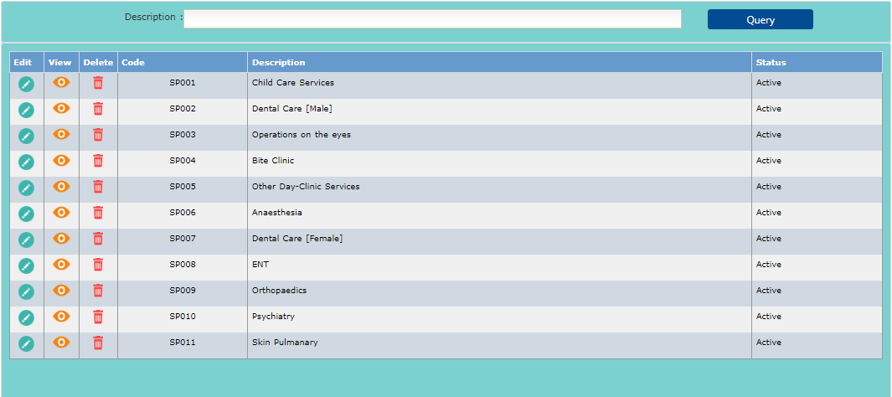

**Add Page**

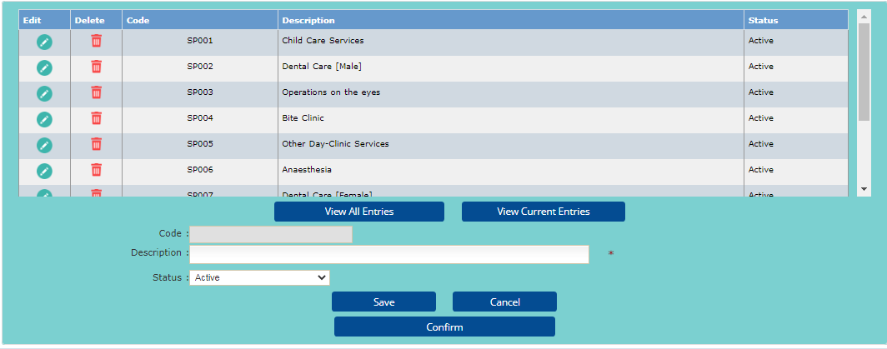

1. Service Master

**List Page**

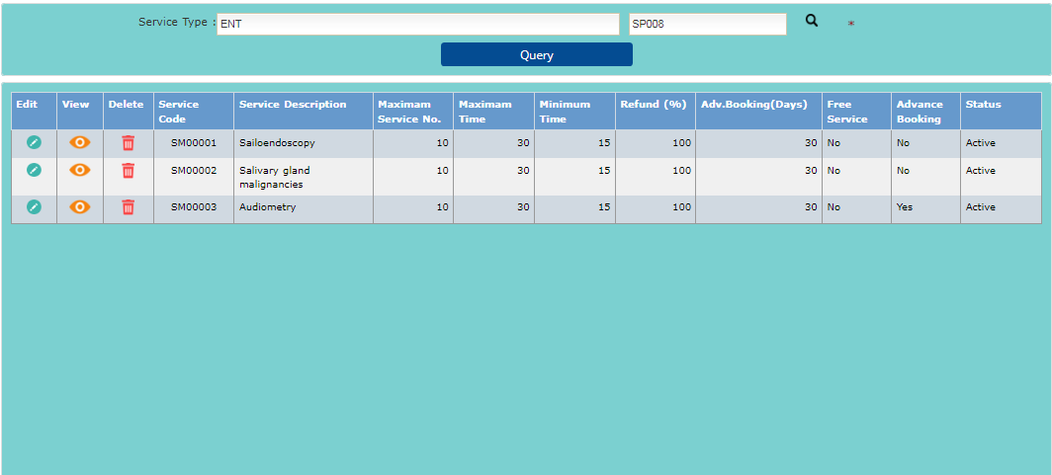

**Add Page**

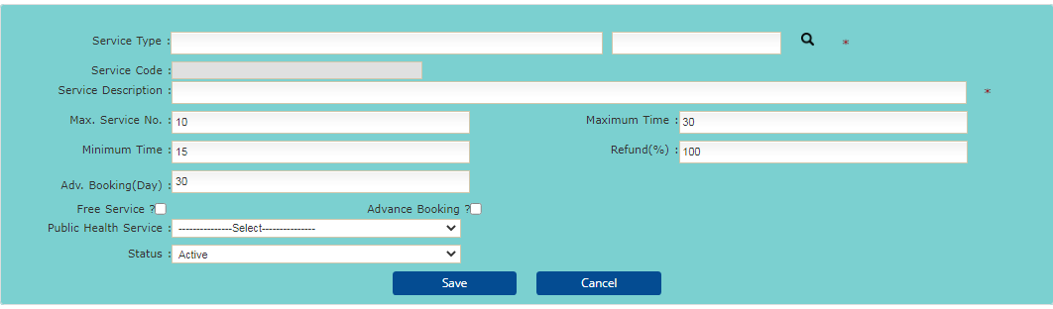

1. Tariff Category Master

**List Page**

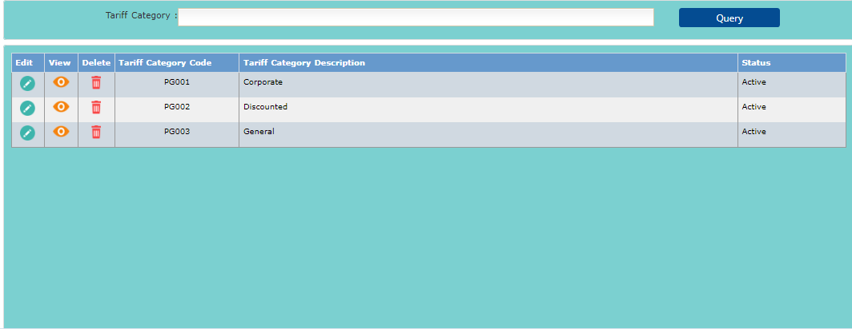

**Add Page**

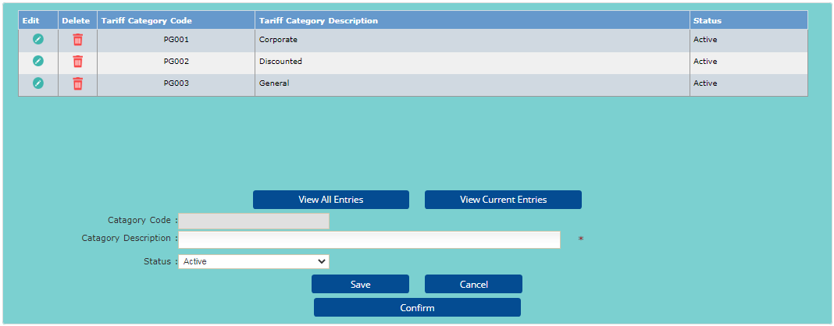

1. Service Rate Master

**List Page**

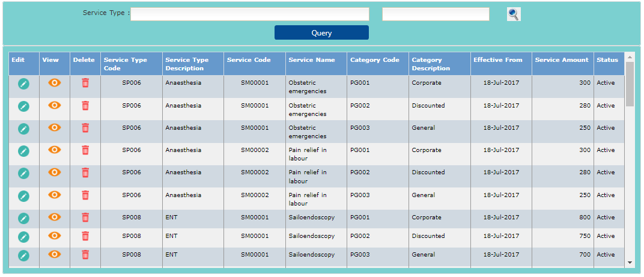

**Add Page**

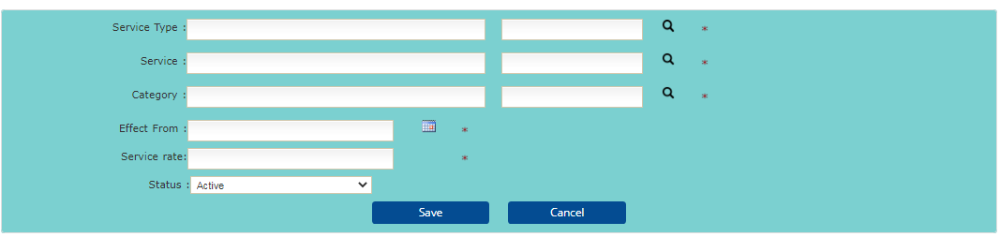

1. Day-Clinic Type Master

**List Page**

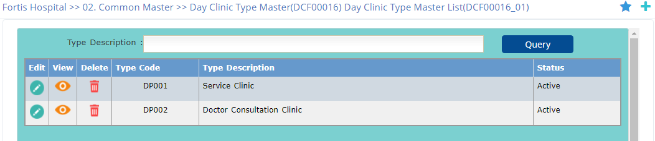

**Add Page**

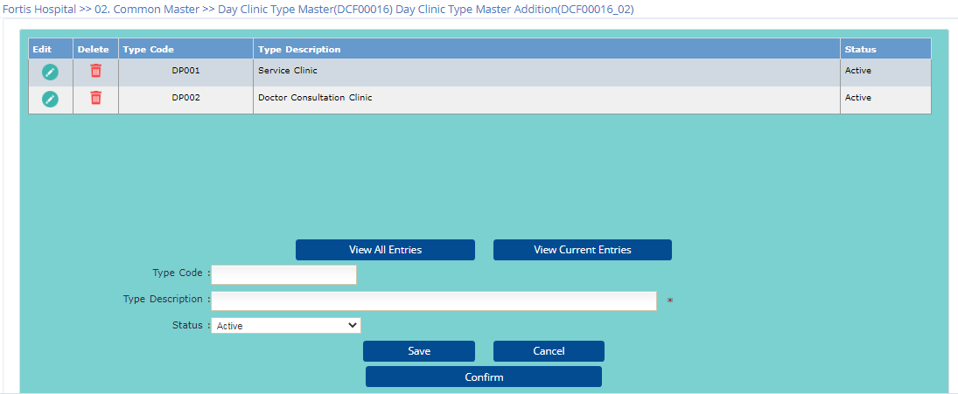

1. Day-Clinic Master

**List Page**

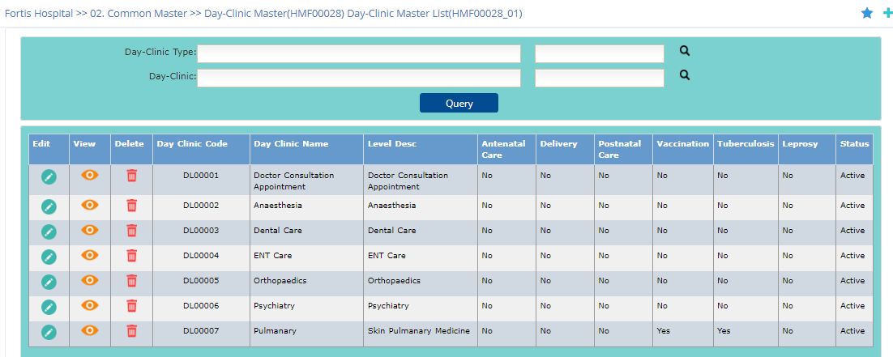

**Add Page**

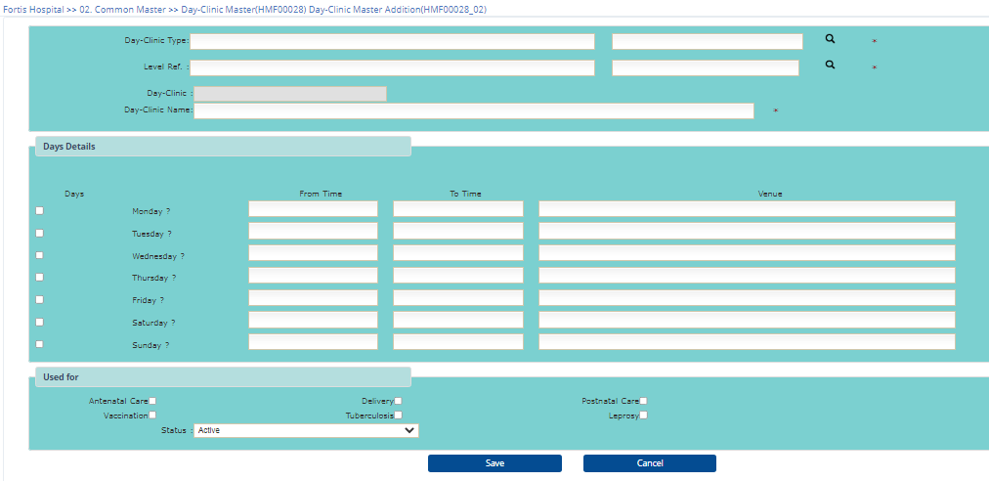

1. Day-Clinic wise Service Mapping

**List Page**

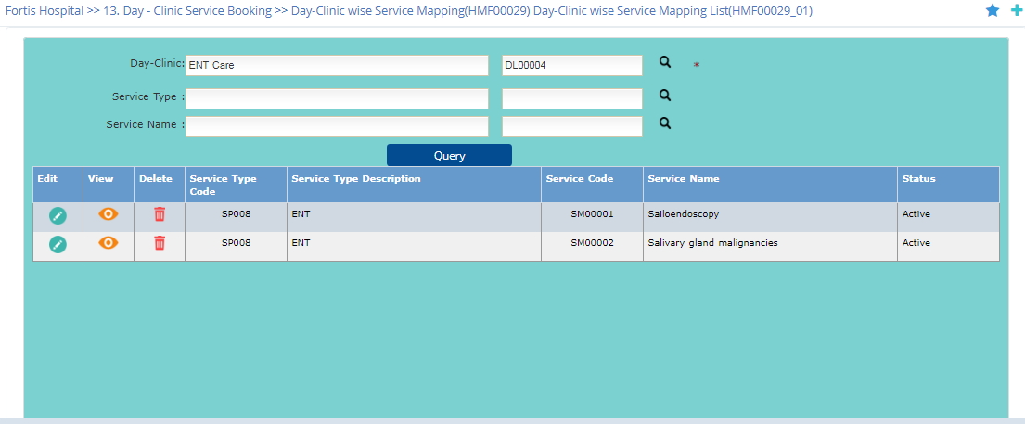

**Add Page**

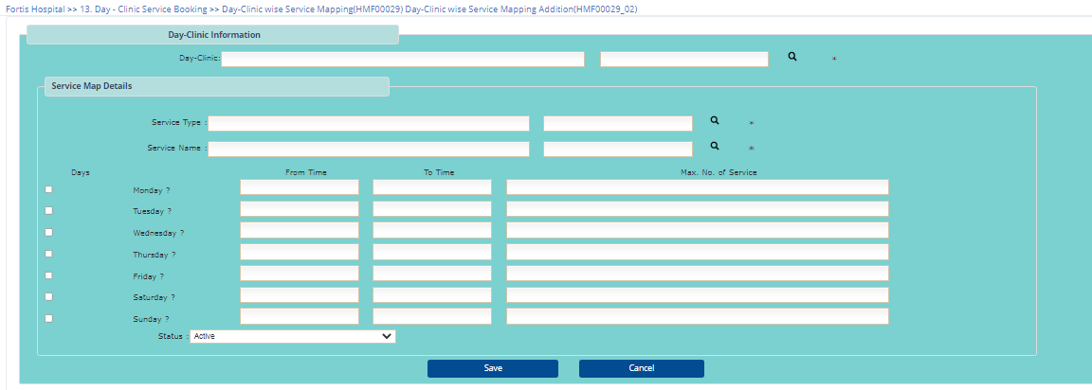

1. Day-Clinic Roster

**List Page**

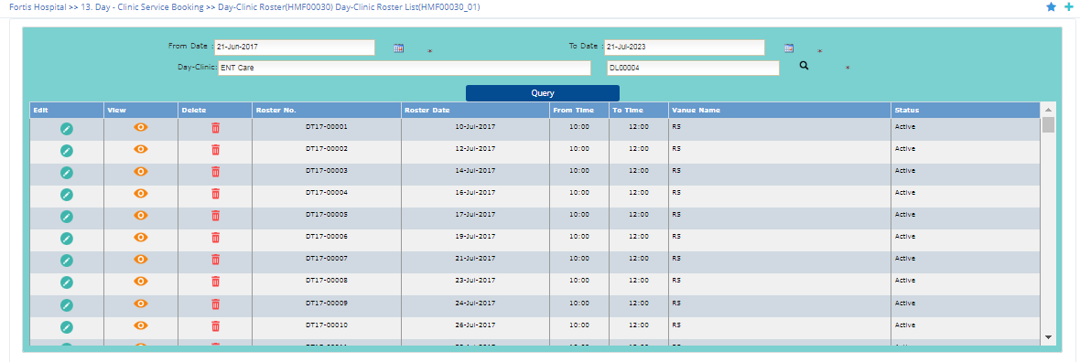

**Add Page**

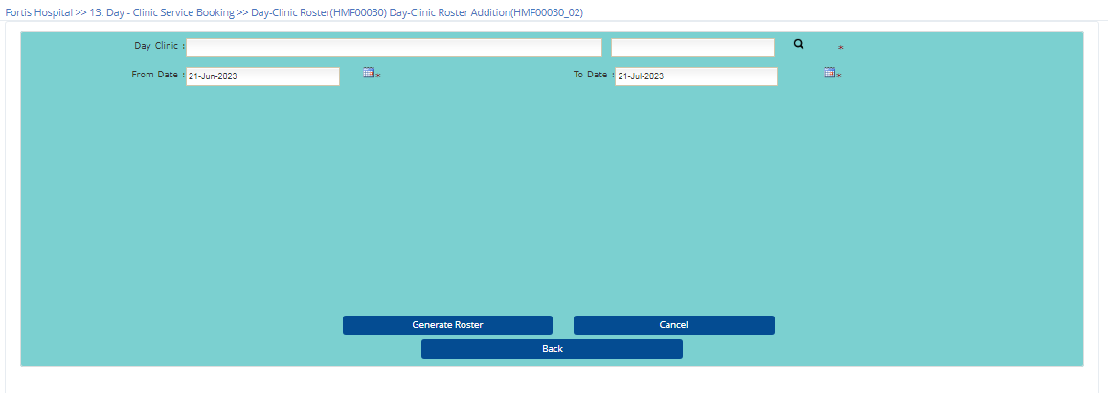

1. Cancellation Reason Type Master

**List Page**

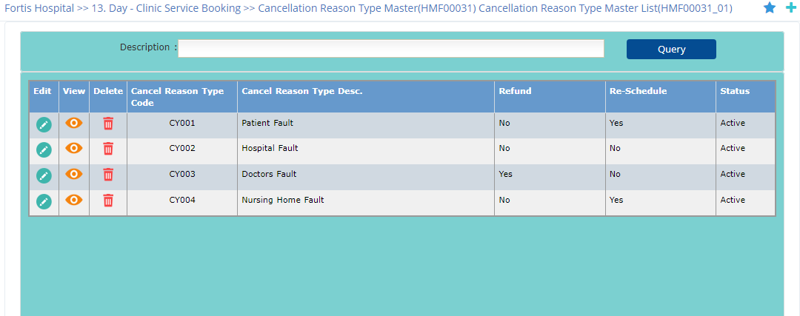

**Add Page**

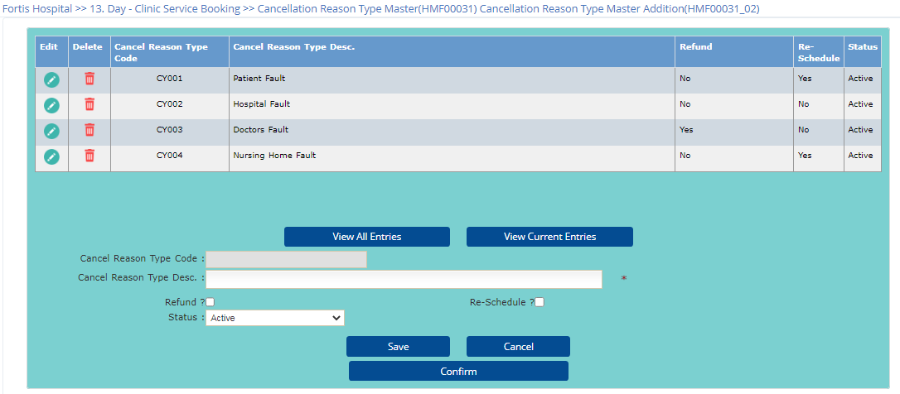

1. Cancellation Reason Master

**List Page**

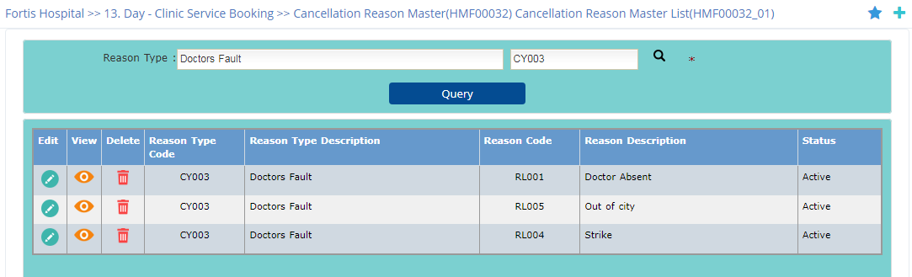

1. **Transaction**
   1. Service Booking

**List Page**

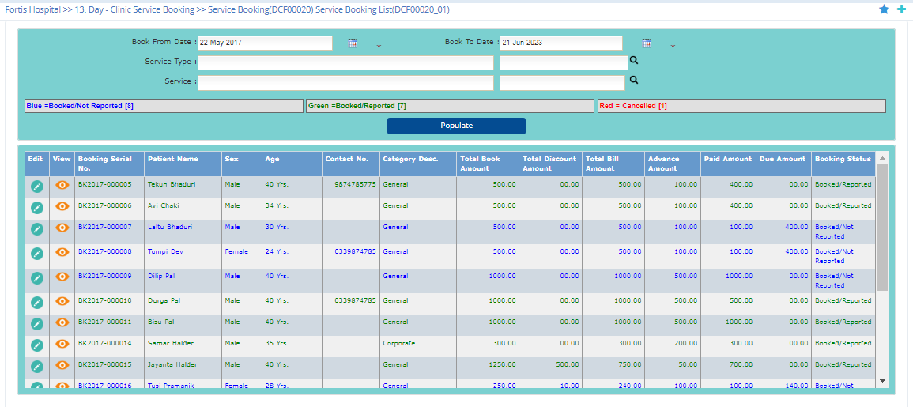

**Add Page**

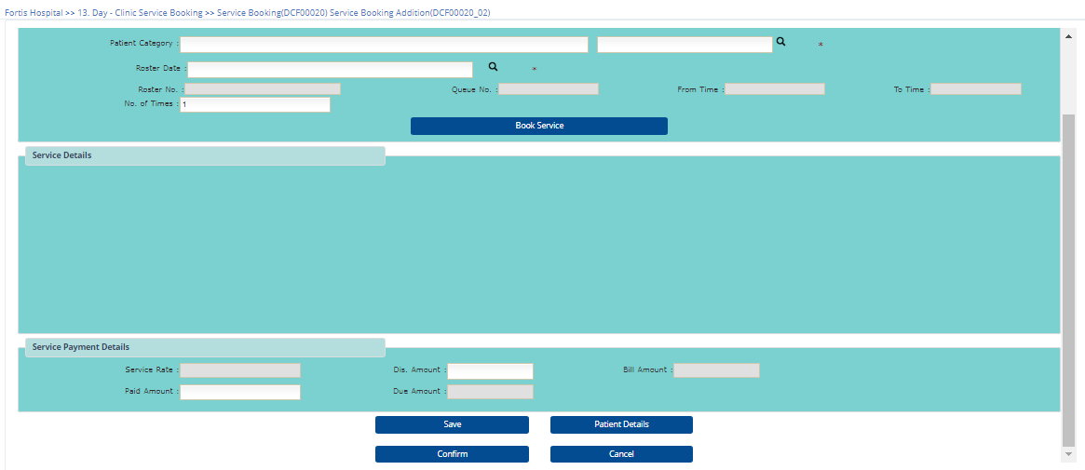

* 1. Patient Booking

**List Page**

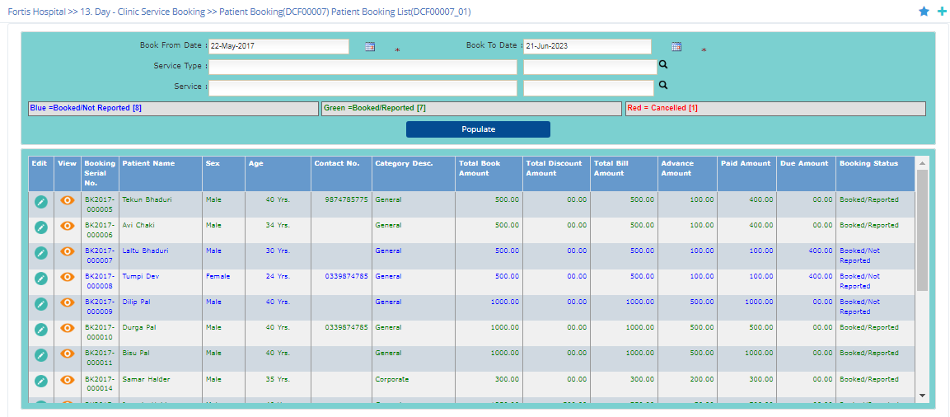

**Add Page**

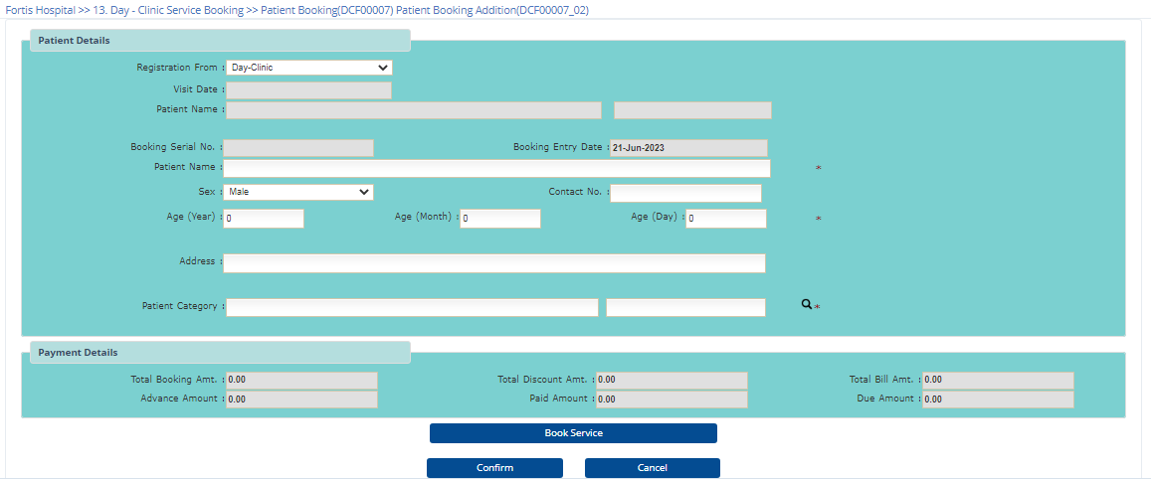

* 1. Patient Reporting

**List Page**

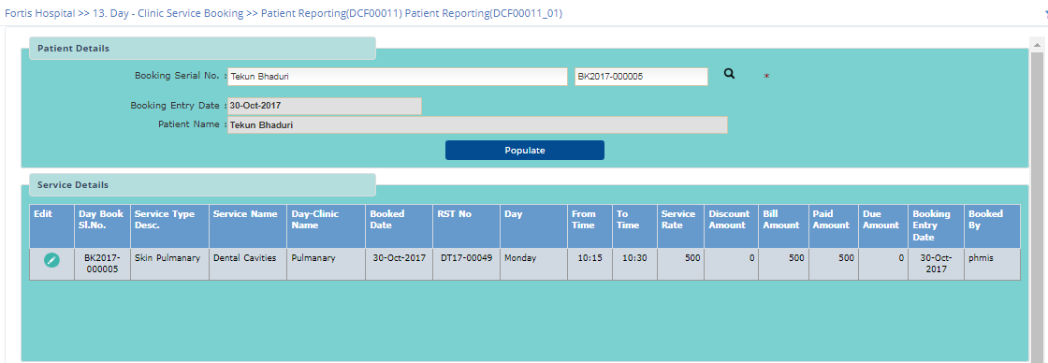

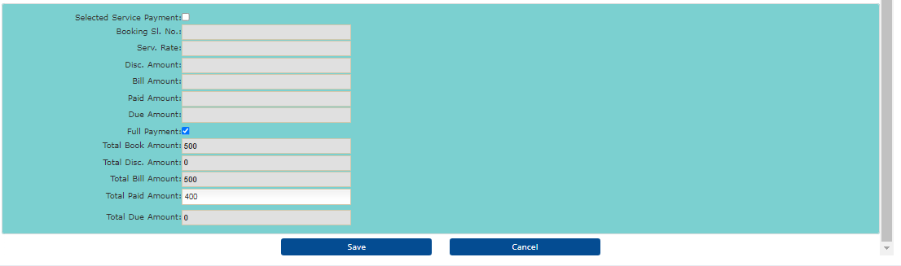

* 1. Booking Cancellation

2.4.1 Patient Booking Cancellation

**List Page**

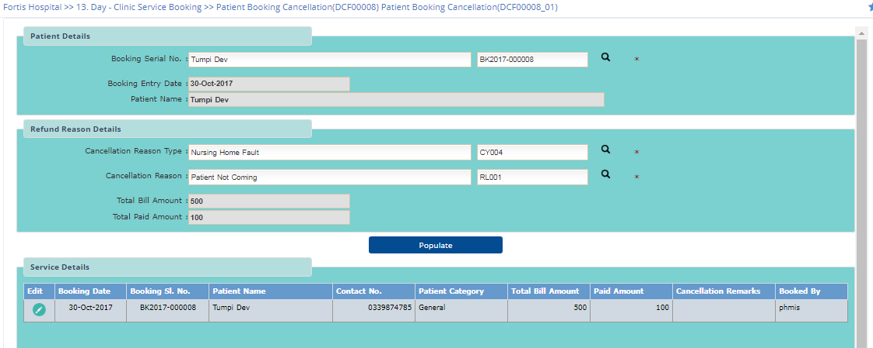

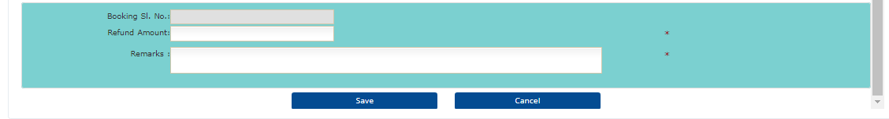

2..2 Service Booking Cancellation

**List Page**

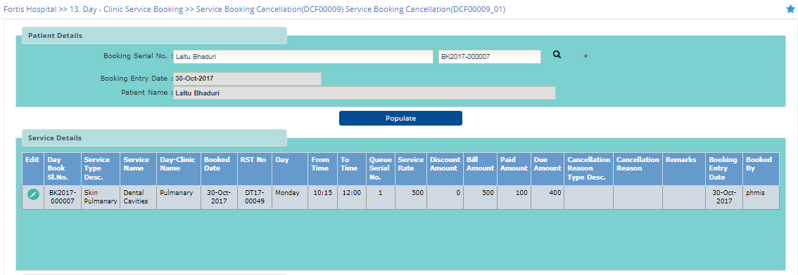

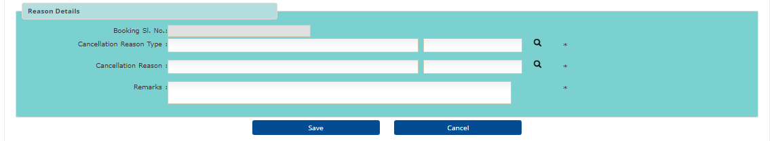

* 1. Advance Refund

**List Page**

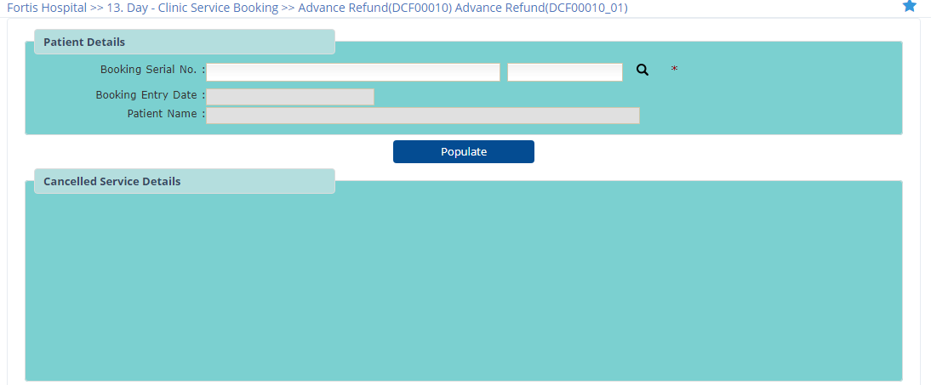

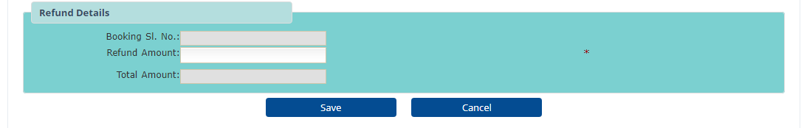

1. **View**
2. Day Clinic Service Roaster
3. Day Clinic wise list of available service

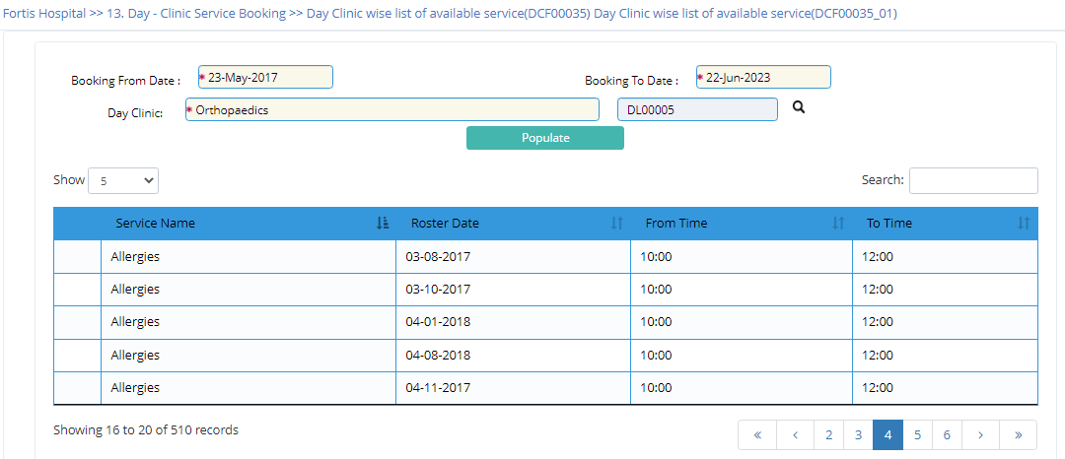

1. Collection Analysis
2. Day Clinic wise and Date wise Collection(Service)

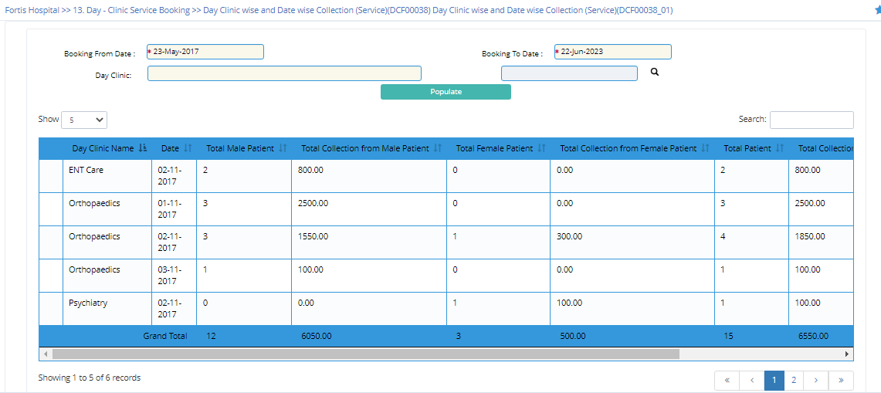

1. Day Clinic wise monthly Collection(Service)

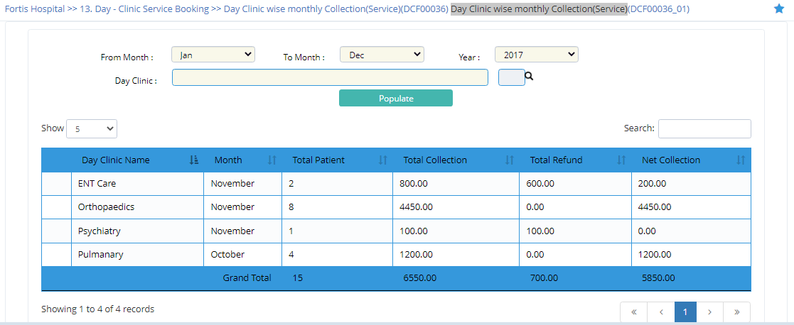

1. Service wise and Date wise Collection

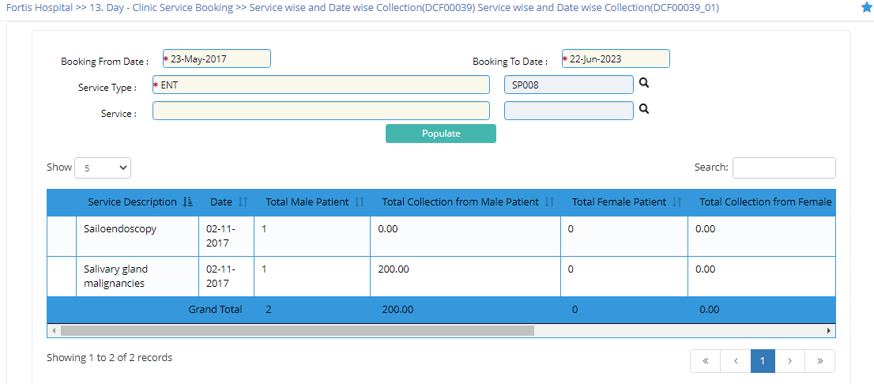

1. Service wise monthly Collection

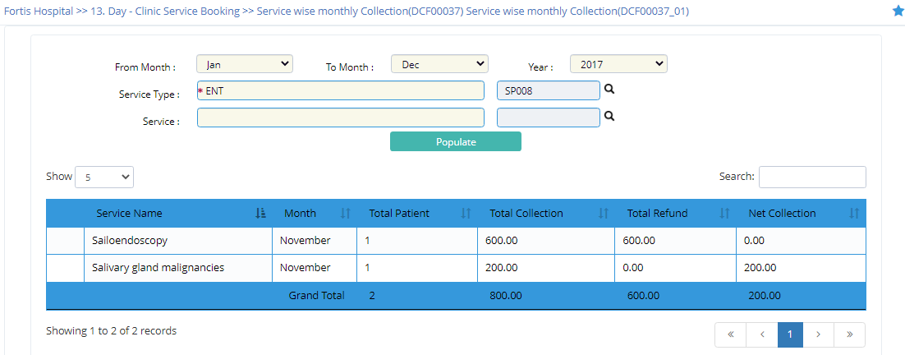

1. Register Report
2. Day Clinic Booking Register

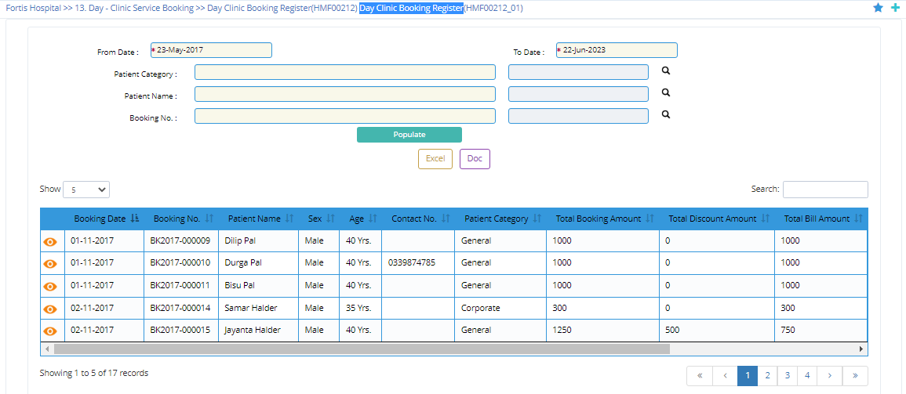

1. Day Clinic Service Booking Register

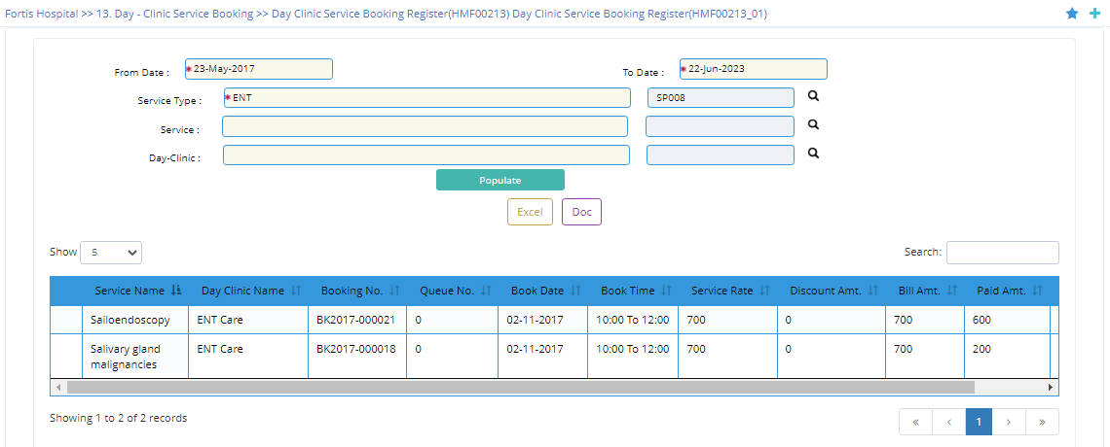

1. Day Clinic Wise Collection Register

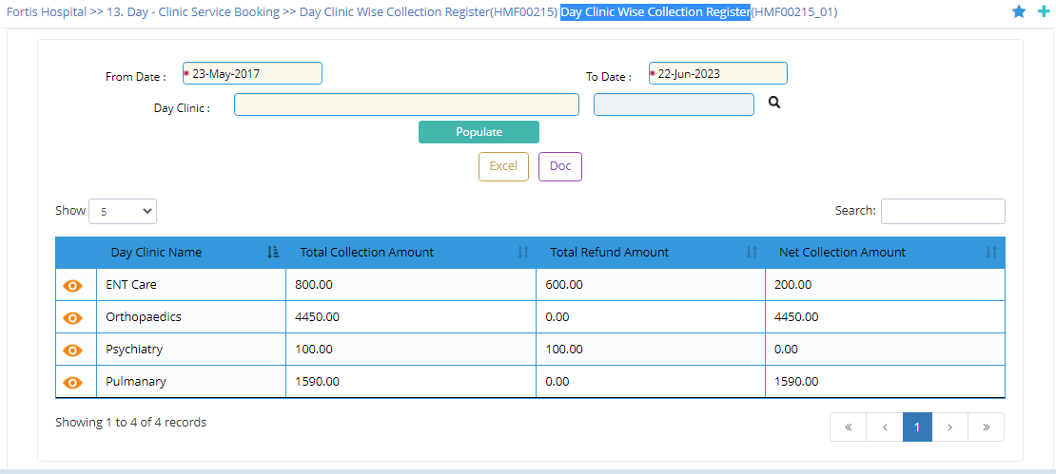

1. Day clinic Wise Refund Register

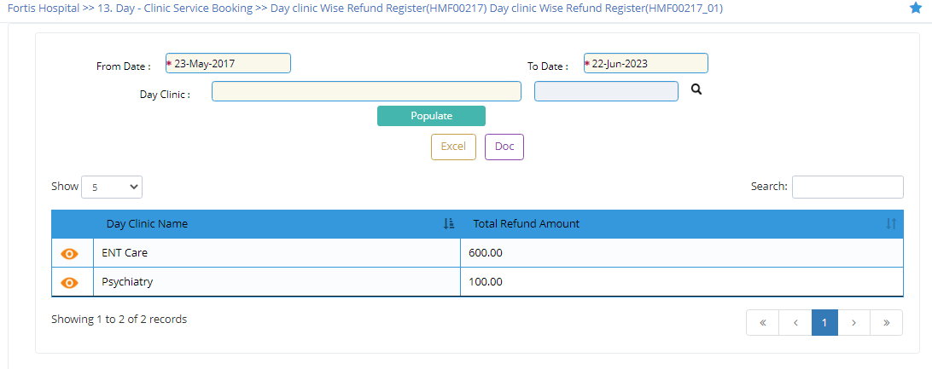

1. User Wise Collection Register

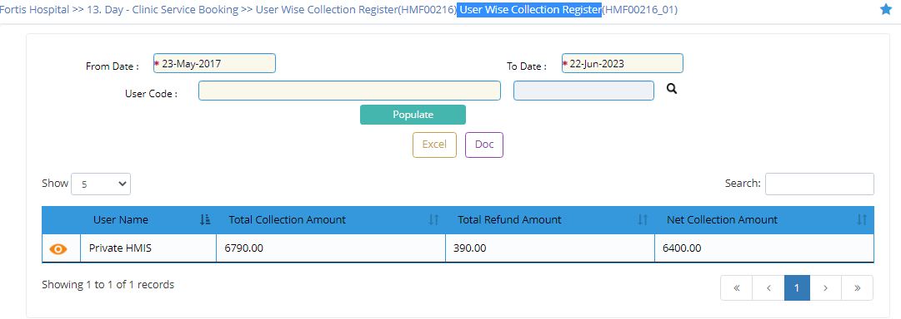

1. User Wise Refund Register

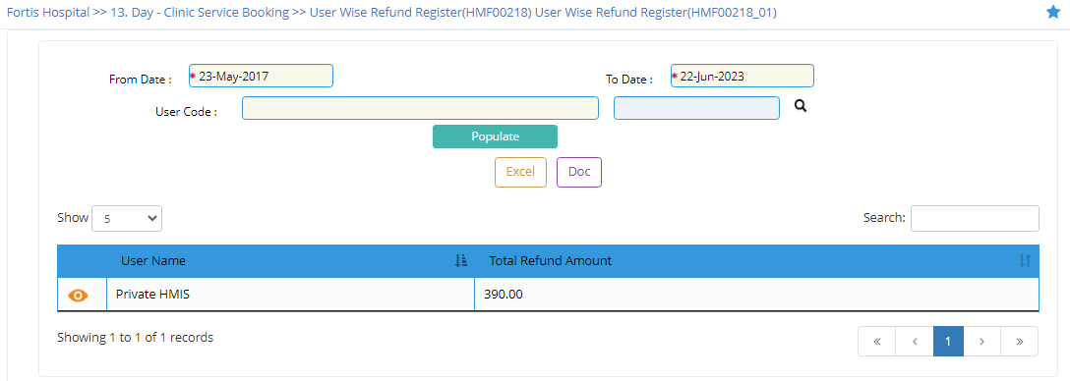

1. Patient Booking Cancellation Register

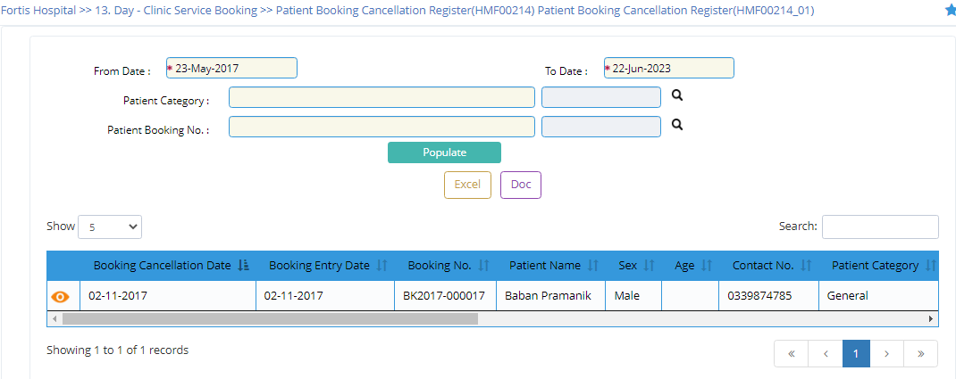

*****************************************************************************************************************************

No. : 1

Module Group : HMIS Web V2

Module : 105 Day-Clinic Common

Object Type : Table

Object : DAY_CLINIC_TYP_MST

Description : Day Clinic Type Master

File Name : M0389_0002

Object Category: Master Table

*****************************************************************************************************************************

Create Table **DAY_CLINIC_TYP_MST(**

DAY_CLINIC_TYP_CD Text(5) Not Null , ' Day Clinic Type Code

DAY_CLINIC_TYP_DESC Text(100) Not Null , ' Day Clinic Type Description

ACT_FLG Text(1) Default 'A' Not Null , ' Active Flag (Active-"A",Inactive-"I",Delete

' -"D")

MOD_DT Date(8) Not Null , ' Modification Date

Constraint PK001_M0389_0002 Primary Key (DAY_CLINIC_TYP_CD),

Constraint CK001_M0389_0002 Check Key (ACT_FLG) ('A','I','D')

);

*****************************************************************************************************************************

No. : 2

Module Group : HMIS Web V2

Module : 105 Day-Clinic Common

Object Type : Table

Object : DAY_CLINIC_MST

Description : Day Clinic Master

File Name : M0389_0001

Object Category: Master Table

*****************************************************************************************************************************

Create Table DAY_CLINIC_MST(

HOS_CD Text(10) Not Null , ' Hospital Code

DAY_CLINIC_CD Text(10) Not Null , ' Day Clinic Code

DAY_CLINIC_NM Text(100) Not Null , ' Day Clinic Name

DAY_CLINIC_TYP_CD Text(5) Not Null , ' Day Clinic Type Code

UNIT_DEPD_FLG Text(1) Default 'N' Not Null , ' Unit Dependent Flag

MON_FLG Text(1) Default 'N' Not Null , ' Monday Flag

TUE_FLG Text(1) Default 'N' Not Null , ' Tuesday Flag

WED_FLG Text(1) Default 'N' Not Null , ' Wednesday Flag

THU_FLG Text(1) Default 'N' Not Null , ' Thursday Flag

FRI_FLG Text(1) Default 'N' Not Null , ' Friday Flag

SAT_FLG Text(1) Default 'N' Not Null , ' Saterday Flag (Y-Yes, N-No)

SUN_FLG Text(1) Default 'N' Not Null , ' Sunday Flag (Y-Yes, N-No)

MON_FR_TM Text(5) , ' Monday From Time

MON_TO_TM Text(5) , ' Monday To Time

TUE_FR_TM Text(5) , ' Tuesday From Time

TUE_TO_TM Text(5) , ' Tuesday Flag

WED_FR_TM Text(5) , ' Wednesday From Time

WED_TO_TM Text(5) , ' Wednesday To Time

THU_FR_TM Text(5) , ' Thrusday From Time

THU_TO_TM Text(5) , ' Thursday To Time

FRI_FR_TM Text(5) , ' Friday From Time

FRI_TO_TM Text(5) , ' Friday To Time

SAT_FR_TM Text(5) , ' Saturday From Time

SAT_TO_TM Text(5) , ' Saterday To Time

SUN_FR_TM Text(5) , ' Sunday From Time

SUN_TO_TM Text(5) , ' Sunday To Time

MON_VENUE_NM Text(50) , ' Monday Venue Name

TUE_VENUE_NM Text(50) , ' Tueasday Venue Name

WED_VENUE_NM Text(50) , ' Wednesday Venue Name

THU_VENUE_NM Text(50) , ' Thrusday Venue Name

FRI_VENUE_NM Text(50) , ' Friday Venue Name

SAT_VENUE_NM Text(50) , ' Saturday Venue Name

SUN_VENUE_NM Text(50) , ' Sunday Venue Name

PH_ANC_FLG Text(1) Default 'N' Not Null , ' Public Health Antenatal Care Flag ([Y]es, [

' N]o)

PH_DLV_FLG Text(1) Default 'N' Not Null , ' Public Health Delivery Flag ([Y]es, [N]o)

PH_PNC_FLG Text(1) Default 'N' Not Null , ' Public Health Postnatal Care Flag ([Y]es, [

' N]o)

PH_VAC_FLG Text(1) Default 'N' Not Null , ' Public Health Vaccination Flag ([Y]es, [N]o

' )

PH_RNTCP_FLG Text(1) Default 'N' Not Null , ' Public Health Revised National Tuberculosis

' Control Program Flag ([Y]es, [N]o)

PH_NLEP_FLG Text(1) Default 'N' Not Null , ' Public Health National Leprosy Elimination

' Program Flag ([Y]es, [N]o)

BASE_LVL_REF_CD Text(6) Not Null , ' Hospital Level Referrence Code

LVL_REF_CD Text(6) Not Null , ' Level. Ref. Code

ACTIVE_FLG Text(1) Default 'Y' Not Null , ' Active Flag ([Y]es / [N]o)

ENTRY_DT Date(8) Not Null , ' Entry Date

USER_CD Text(10) Not Null , ' User Code

SESSION_ID Numeric(9) Not Null , ' Session Id

MOD_ID Text(2) Not Null , ' Module ID

SUB_MOD_ID Text(3) Not Null , ' Sub Module ID

ACT_FLG Text(1) Default 'A' Not Null , ' Active Flag (Active-"A",Inactive-"I",Delete

' -"D")

MOD_DT Date(8) , ' Modification Date

SESSION_ID_WEB Text(30) , ' Session ID for Web Development

Constraint PK001_M0389_0001 Primary Key (HOS_CD,DAY_CLINIC_CD),

Constraint FK001_M0389_0001 Foreign Key (DAY_CLINIC_TYP_CD) References (DAY_CLINIC_TYP_MST) (DAY_CLINIC_TYP_CD) ,

Constraint FK002_M0389_0001 Foreign Key (BASE_LVL_REF_CD,LVL_REF_CD) References (MDT_LOC_LVL_REF_MST) (BASE_LVL_REF_CD,LVL_REF_CD

CD)

Constraint CK001_M0389_0001 Check Key (SUN_FLG ('Y','N'),

Constraint CK002_M0389_0001 Check Key (FRI_FLG ('Y','N'),

Constraint CK003_M0389_0001 Check Key (SAT_FLG ('Y','N'),

Constraint CK004_M0389_0001 Check Key (MON_FLG ('Y','N'),

Constraint CK005_M0389_0001 Check Key (TUE_FLG ('Y','N'),

Constraint CK006_M0389_0001 Check Key (WED_FLG ('Y','N'),

Constraint CK007_M0389_0001 Check Key (THU_FLG ('Y','N'),

Constraint CK008_M0389_0001 Check Key (ACTIVE_FLG ('Y','N'),

Constraint CK009_M0389_0001 Check Key (PH_RNTCP_FLG ('Y','N'),

Constraint CK010_M0389_0001 Check Key (PH_NLEP_FLG ('Y','N'),

Constraint CK011_M0389_0001 Check Key (PH_ANC_FLG ('Y','N'),

Constraint CK012_M0389_0001 Check Key (PH_DLV_FLG ('Y','N'),

Constraint CK013_M0389_0001 Check Key (PH_PNC_FLG ('Y','N'),

Constraint CK014_M0389_0001 Check Key (PH_VAC_FLG ('Y','N'),

Constraint CK015_M0389_0001 Check Key (UNIT_DEPD_FLG ('Y','N'),

Constraint CK016_M0389_0001 Check Key (ACT_FLG) ('A','I','D')

);

*****************************************************************************************************************************

No. : 3

Module Group : HMIS Web V2

Module : 105 Day-Clinic Service

Object Type : Table

Object : DAY_SERV_TYP_MST

Description : Day Clinic Service Type Master

File Name : M0390_0004

Object Category: Master Table

*****************************************************************************************************************************

Create Table DAY_SERV_TYP_MST(

SERV_TYP_CD Text(5) Not Null , ' Service Type Code

SERV_TYP_DESC Text(100) Not Null , ' Service Type Description

ACTIVE_FLG Text(1) Default 'Y' Not Null , ' Active Flag ([Y]es / [N]o)

USER_CD Text(10) Not Null , ' User Code

ENTRY_DT Date(8) Not Null , ' Entry Date

SESSION_ID Numeric(9) Not Null , ' Session Id

MOD_ID Text(2) Not Null , ' Module ID

SUB_MOD_ID Text(3) Not Null , ' Sub Module ID

ACT_FLG Text(1) Default 'A' Not Null , ' Active Flag (Active-"A",Inactive-"I",Delete

' -"D")

MOD_DT Date(8) , ' Modification Date

SESSION_ID_WEB Text(30) , ' Session ID for Web Development

Constraint PK001_M0390_0004 Primary Key (SERV_TYP_CD),

Constraint CK001_M0390_0004 Check Key (ACTIVE_FLG ('Y','N'),

Constraint CK002_M0390_0004 Check Key (ACT_FLG) ('A','I','D')

);

*****************************************************************************************************************************

No. : 4

Module Group : HMIS Web V2

Module : 105 Day-Clinic Service

Object Type : Table

Object : DAY_SERV_MST

Description : Day Clinic Service Master

File Name : M0390_0005

Object Category: Master Table

*****************************************************************************************************************************

Create Table DAY_SERV_MST(

SERV_TYP_CD Text(5) Not Null , ' Service Type Code

SERV_CD Text(7) Not Null , ' Service Code

SERV_DESC Text(100) Not Null , ' Service Description

ADV_BOOK_FLG Text(1) Default 'Y' Not Null , ' Advance Booking Flag – [Y]es / [N]o

MAX_SERV_NO Numeric(9) Default 0 Not Null , ' Maximum Service No.

MAX_TM Text(5) Not Null , ' Maximum Execution Time of Service

MIN_TM Text(5) Not Null , ' Minimum Execution Time of Service

FREE_FLG Text(1) Default 'N' Not Null , ' Free flag (Yes-"Y",No-"N")

REFUND_PER Float(8) Default 100 Not Null , ' Refund Percentage

UNIT_DEPD_FLG Text(1) Default 'N' Not Null , ' Unit Dependent Flag

PH_ANC_FLG Text(1) Default 'N' Not Null , ' Public Health Antenatal Care Flag ([Y]es, [

' N]o)

PH_DLV_FLG Text(1) Default 'N' Not Null , ' Public Health Delivery Flag ([Y]es, [N]o)

PH_PNC_FLG Text(1) Default 'N' Not Null , ' Public Health Postnatal Care Flag ([Y]es, [

' N]o)

PH_VAC_FLG Text(1) Default 'N' Not Null , ' Public Health Vaccination Flag ([Y]es, [N]o

' )

PH_RNTCP_FLG Text(1) Default 'N' Not Null , ' Public Health Revised National Tuberculosis

' Control Program Flag ([Y]es, [N]o)

PH_NLEP_FLG Text(1) Default 'N' Not Null , ' Public Health National Leprosy Elimination

' Program Flag ([Y]es, [N]o)

ACTIVE_FLG Text(1) Default 'Y' Not Null , ' Active Flag ([Y]es / [N]o)

USER_CD Text(10) Not Null , ' User Code

ENTRY_DT Date(8) Not Null , ' Entry Date

SESSION_ID Numeric(9) Not Null , ' Session Id

ADV_DAY Numeric(9) Default 30 Not Null , ' Advance Booking Allow Upto Days

MOD_ID Text(2) Not Null , ' Module ID

SUB_MOD_ID Text(3) Not Null , ' Sub Module ID

ACT_FLG Text(1) Default 'A' Not Null , ' Active Flag (Active-"A",Inactive-"I",Delete

' -"D")

MOD_DT Date(8) , ' Modification Date

SESSION_ID_WEB Text(30) , ' Session ID for Web Development

Constraint PK001_M0390_0005 Primary Key (SERV_TYP_CD,SERV_CD),

Constraint FK001_M0390_0005 Foreign Key (SERV_TYP_CD) References (DAY_SERV_TYP_MST) (SERV_TYP_CD) ,

Constraint CK011_M0390_0005 Check Key (PH_ANC_FLG ('Y','N'),

Constraint CK009_M0390_0005 Check Key (FREE_FLG ('Y','N'),

Constraint CK010_M0390_0005 Check Key (UNIT_DEPD_FLG ('Y','N'),

Constraint CK001_M0390_0005 Check Key (ACT_FLG ('A','I','D'),

Constraint CK002_M0390_0005 Check Key (PH_DLV_FLG ('Y','N'),

Constraint CK003_M0390_0005 Check Key (PH_PNC_FLG ('Y','N'),

Constraint CK004_M0390_0005 Check Key (PH_VAC_FLG ('Y','N'),

Constraint CK005_M0390_0005 Check Key (PH_RNTCP_FLG ('Y','N'),

Constraint CK006_M0390_0005 Check Key (PH_NLEP_FLG ('Y','N'),

Constraint CK007_M0390_0005 Check Key (ACTIVE_FLG ('Y','N'),

Constraint CK008_M0390_0005 Check Key (ADV_BOOK_FLG) ('Y','N')

);

*****************************************************************************************************************************

No. : 5

Module Group : HMIS Web V2

Module : 105 Day-Clinic Service

Object Type : Table

Object : DAY_PAT_CAT_MST

Description : Patient Category Master

File Name : M0390_0001

Object Category: Master Table

*****************************************************************************************************************************

Create Table DAY_PAT_CAT_MST(

HOS_CD Text(10) Not Null , ' Hospital Code

CAT_CD Text(10) Not Null , ' Category Code

CAT_DESC Text(100) Not Null , ' Category Description

ACTIVE_FLG Text(1) Default 'Y' Not Null , ' Active Flag ([Y]es / [N]o)

ENTRY_DT Date(8) Not Null , ' Entry Date

USER_CD Text(10) Not Null , ' User Code

SESSION_ID Numeric(9) Not Null , ' Session Id

MOD_ID Text(2) Not Null , ' Module ID

SUB_MOD_ID Text(3) Not Null , ' Sub Module ID

ACT_FLG Text(1) Default 'A' Not Null , ' Active Flag (Active-"A",Inactive-"I",Delete

' -"D")

MOD_DT Date(8) , ' Modification Date

SESSION_ID_WEB Text(30) , ' Session ID for Web Development

Constraint PK001_M0390_0001 Primary Key (HOS_CD,CAT_CD),

Constraint CK001_M0390_0001 Check Key (ACTIVE_FLG ('Y','N'),

Constraint CK002_M0390_0001 Check Key (ACT_FLG) ('A','I','D')

);

*****************************************************************************************************************************

No. : 6

Module Group : HMIS Web V2

Module : 105 Day-Clinic Service

Object Type : Table

Object : DAY_SERV_RATE_MST

Description : Day Clinic Service Rate Master

File Name : M0390_0006

Object Category: Master Table

*****************************************************************************************************************************

Create Table DAY_SERV_RATE_MST(

HOS_CD Text(10) Not Null , ' Hospital Code

SERV_TYP_CD Text(5) Not Null , ' Service Type Code

SERV_CD Text(7) Not Null , ' Service Code

CAT_CD Text(10) Not Null , ' Category Code

EFFECT_DT Date(8) Not Null , ' Effective Date

SERV_AMT Float(8) Default 0 Not Null , ' Service Amount

ENTRY_DT Date(8) Not Null , ' Entry Date

USER_CD Text(10) Not Null , ' User Code

SESSION_ID Numeric(9) Not Null , ' Session Id

ACT_FLG Text(1) Default 'A' Not Null , ' Active Flag (Active-"A",Inactive-"I",Delete

' -"D")

MOD_DT Date(8) , ' Modification Date

SESSION_ID_WEB Text(30) , ' Session ID for Web Development

Constraint PK001_M0390_0006 Primary Key (HOS_CD,SERV_TYP_CD,SERV_CD,CAT_CD,EFFECT_DT),

Constraint FK002_M0390_0006 Foreign Key (SERV_TYP_CD,SERV_CD) References (DAY_SERV_MST) (SERV_TYP_CD,SERV_CD) ,

Constraint FK001_M0390_0006 Foreign Key (HOS_CD,CAT_CD) References (DAY_PAT_CAT_MST) (HOS_CD,CAT_CD) ,

Constraint CK001_M0390_0006 Check Key (ACT_FLG) ('A','I','D')

);

*****************************************************************************************************************************

No. : 7

Module Group : HMIS Web V2

Module : 105 Day-Clinic Service

Object Type : Table

Object : DAY_SERV_MAP

Description : Day Clinic and Day Clinic Service Mapping

File Name : M0390_0007

Object Category: Mapping Table

*****************************************************************************************************************************

Create Table DAY_SERV_MAP(

HOS_CD Text(10) Not Null , ' Hospital Code

DAY_CLINIC_CD Text(10) Not Null , ' Day Clinic Code

SERV_TYP_CD Text(5) Not Null , ' Service Type Code

SERV_CD Text(7) Not Null , ' Service Code

SUN_AVL_FLG Text(1) Default 'N' Not Null , ' Sunday Available Flag ([Y]es / [N]o).

MON_AVL_FLG Text(1) Default 'N' Not Null , ' Monday Available Flag ([Y]es / [N]o).

TUE_AVL_FLG Text(1) Default 'N' Not Null , ' Tuesday Available Flag ([Y]es / [N]o).

WED_AVL_FLG Text(1) Default 'N' Not Null , ' Wednesday Available Flag ([Y]es / [N]o).

THU_AVL_FLG Text(1) Default 'N' Not Null , ' Thursday Available Flag ([Y]es / [N]o).

FRI_AVL_FLG Text(1) Default 'N' Not Null , ' Friday Available Flag ([Y]es / [N]o).

SAT_AVL_FLG Text(1) Default 'N' Not Null , ' Saturday Available Flag ([Y]es / [N]o).

SUN_FR_TM Text(5) , ' Sunday From Time

SUN_TO_TM Text(5) , ' Sunday To Time

MON_FR_TM Text(5) , ' Monday From Time

MON_TO_TM Text(5) , ' Monday To Time

TUE_FR_TM Text(5) , ' Tuesday From Time

TUE_TO_TM Text(5) , ' Tuesday Flag

WED_FR_TM Text(5) , ' Wednesday From Time

WED_TO_TM Text(5) , ' Wednesday To Time

THU_FR_TM Text(5) , ' Thrusday From Time

THU_TO_TM Text(5) , ' Thursday To Time

FRI_FR_TM Text(5) , ' Friday From Time

FRI_TO_TM Text(5) , ' Friday To Time

SAT_FR_TM Text(5) , ' Saturday From Time

SAT_TO_TM Text(5) , ' Saterday To Time

SUN_SERV_MAX_NO Numeric(9) Default 0 Not Null , ' Maximum No. of Service given on Sunday.

MON_SERV_MAX_NO Numeric(9) Default 0 Not Null , ' Maximum No. of Service given on Monday.

TUE_SERV_MAX_NO Numeric(9) Default 0 Not Null , ' Maximum No. of Service given on Tuesday.

WED_SERV_MAX_NO Numeric(9) Default 0 Not Null , ' Maximum No. of Service given on Wednesday.

THU_SERV_MAX_NO Numeric(9) Default 0 Not Null , ' Maximum No. of Service given on Thursday.

FRI_SERV_MAX_NO Numeric(9) Default 0 Not Null , ' Maximum No. of Service given on Friday.

SAT_SERV_MAX_NO Numeric(9) Default 0 Not Null , ' Maximum No. of Service given on Saturday.

ENTRY_DT Date(8) Not Null , ' Entry Date

USER_CD Text(10) Not Null , ' User Code

SESSION_ID Numeric(9) Not Null , ' Session Id

MOD_ID Text(2) Not Null , ' Module ID

SUB_MOD_ID Text(3) Not Null , ' Sub Module ID

ACT_FLG Text(1) Default 'A' Not Null , ' Active Flag (Active-"A",Inactive-"I",Delete

' -"D")

MOD_DT Date(8) , ' Modification Date

Constraint PK001_M0390_0007 Primary Key (HOS_CD,DAY_CLINIC_CD,SERV_TYP_CD,SERV_CD),

Constraint FK001_M0390_0007 Foreign Key (SERV_TYP_CD,SERV_CD) References (DAY_SERV_MST) (SERV_TYP_CD,SERV_CD) ,

Constraint FK002_M0390_0007 Foreign Key (HOS_CD,DAY_CLINIC_CD) References (DAY_CLINIC_MST) (HOS_CD,DAY_CLINIC_CD) ,

Constraint CK001_M0390_0007 Check Key (WED_AVL_FLG ('Y','N'),

Constraint CK002_M0390_0007 Check Key (MON_AVL_FLG ('Y','N'),

Constraint CK003_M0390_0007 Check Key (TUE_AVL_FLG ('Y','N'),

Constraint CK004_M0390_0007 Check Key (SAT_AVL_FLG ('Y','N'),

Constraint CK005_M0390_0007 Check Key (THU_AVL_FLG ('Y','N'),

Constraint CK006_M0390_0007 Check Key (FRI_AVL_FLG ('Y','N'),

Constraint CK007_M0390_0007 Check Key (SUN_AVL_FLG ('Y','N'),

Constraint CK008_M0390_0007 Check Key (ACT_FLG) ('A','I','D')

);

*****************************************************************************************************************************

No. : 8

Module Group : HMIS Web V2

Module : 105 Day-Clinic Service

Object Type : Table

Object : DAY_DLY_RST

Description : Day Clinic Daily Roster

File Name : M0390_0008

Object Category: Details Table

*****************************************************************************************************************************

Create Table DAY_DLY_RST(

HOS_CD Text(10) Not Null , ' Hospital Code

DAY_CLINIC_CD Text(10) Not Null , ' Day Clinic Code

RST_DT Date(8) Not Null , ' Roster Date

RST_NO Text(10) Not Null , ' Roster No.

UNIT_DEPD_FLG Text(1) Default 'N' Not Null , ' Unit Dependent Flag

FROM_TM Text(5) Not Null , ' From Time

TO_TM Text(5) Not Null , ' To Time

VENUE_NM Text(50) , ' Venue Name

PH_ANC_FLG Text(1) Default 'N' Not Null , ' Public Health Antenatal Care Flag ([Y]es, [

' N]o)

PH_DLV_FLG Text(1) Default 'N' Not Null , ' Public Health Delivery Flag ([Y]es, [N]o)

PH_PNC_FLG Text(1) Default 'N' Not Null , ' Public Health Postnatal Care Flag ([Y]es, [

' N]o)

PH_VAC_FLG Text(1) Default 'N' Not Null , ' Public Health Vaccination Flag ([Y]es, [N]o

' )

PH_RNTCP_FLG Text(1) Default 'N' Not Null , ' Public Health Revised National Tuberculosis

' Control Program Flag ([Y]es, [N]o)

PH_NLEP_FLG Text(1) Default 'N' Not Null , ' Public Health National Leprosy Elimination

' Program Flag ([Y]es, [N]o)

ACTIVE_FLG Text(1) Default 'Y' Not Null , ' Active Flag ([Y]es / [N]o)

ENTRY_DT Date(8) Not Null , ' Entry Date

USER_CD Text(10) Not Null , ' User Code

**SESSION_ID Numeric(9) Not Null , ' Session Id**

MOD_ID Text(2) Not Null , ' Module ID

SUB_MOD_ID Text(3) Not Null , ' Sub Module ID

ACT_FLG Text(1) Default 'A' Not Null , ' Active Flag (Active-"A",Inactive-"I",Delete

' -"D")

MOD_DT Date(8) , ' Modification Date

Constraint PK001_M0390_0008 Primary Key (HOS_CD,DAY_CLINIC_CD,RST_DT,RST_NO),

Constraint FK001_M0390_0008 Foreign Key (HOS_CD,DAY_CLINIC_CD) References (DAY_CLINIC_MST) (HOS_CD,DAY_CLINIC_CD) ,

Constraint CK009_M0390_0008 Check Key (ACTIVE_FLG ('Y','N'),

Constraint CK001_M0390_0008 Check Key (ACT_FLG ('A','I','D'),

Constraint CK002_M0390_0008 Check Key (UNIT_DEPD_FLG ('Y','N'),

Constraint CK003_M0390_0008 Check Key (PH_ANC_FLG ('Y','N'),

Constraint CK004_M0390_0008 Check Key (PH_DLV_FLG ('Y','N'),

Constraint CK005_M0390_0008 Check Key (PH_PNC_FLG ('Y','N'),

Constraint CK006_M0390_0008 Check Key (PH_VAC_FLG ('Y','N'),

Constraint CK007_M0390_0008 Check Key (PH_RNTCP_FLG ('Y','N'),

Constraint CK008_M0390_0008 Check Key (PH_NLEP_FLG) ('Y','N')

);

*****************************************************************************************************************************

No. : 9

Module Group : HMIS Web V2

Module : 105 Day-Clinic Service

Object Type : Table

Object : DAY_CNCL_RSN_TYP_MST

Description : Cancellation Reason Type Master

File Name : M0390_0002

Object Category: Master Table

*****************************************************************************************************************************

Create Table DAY_CNCL_RSN_TYP_MST(

CNCL_RSN_TYP_CD Text(5) Not Null , ' Cancellation Reason Type Code

CNCL_RSN_TYP_DESC Text(100) Not Null , ' Cancellation Reason Type Description

REFUND_FLG Text(1) Default 'N' Not Null , ' Refund Flag [Y]es/[N]o

REBOOK_FLG Text(1) Default 'Y' Not Null , ' Re-Booking Flag ([Y]es / [N]o).

ACTIVE_FLG Text(1) Default 'Y' Not Null , ' Active Flag ([Y]es / [N]o)

ENTRY_DT Date(8) Not Null , ' Entry Date

USER_CD Text(10) Not Null , ' User Code

**SESSION_ID Numeric(9) Not Null , ' Session Id**

MOD_ID Text(2) Not Null , ' Module ID

SUB_MOD_ID Text(3) Not Null , ' Sub Module ID

ACT_FLG Text(1) Default 'A' Not Null , ' Active Flag (Active-"A",Inactive-"I",Delete

' -"D")

MOD_DT Date(8) , ' Modification Date

Constraint PK001_M0390_0002 Primary Key (CNCL_RSN_TYP_CD),

Constraint CK001_M0390_0002 Check Key (REBOOK_FLG ('Y','N'),

Constraint CK002_M0390_0002 Check Key (ACTIVE_FLG ('Y','N'),

Constraint CK003_M0390_0002 Check Key (REFUND_FLG ('Y','N'),

Constraint CK004_M0390_0002 Check Key (ACT_FLG) ('A','I','D')

);

*****************************************************************************************************************************

No. : 10

Module Group : HMIS Web V2

Module : 105 Day-Clinic Service

Object Type : Table

Object : DAY_CNCL_RSN_MST

Description : Cancellation Reason Master

File Name : M0390_0003

Object Category: Master Table

*****************************************************************************************************************************

Create Table DAY_CNCL_RSN_MST(

CNCL_RSN_TYP_CD Text(5) Not Null , ' Cancellation Reason Type Code

CNCL_RSN_CD Text(10) Not Null , ' Cancellation Reason Code

CNCL_RSN_DESC Text(200) Not Null , ' Cancellation Reason Description

ACTIVE_FLG Text(1) Default 'Y' Not Null , ' Active Flag ([Y]es / [N]o)

ENTRY_DT Date(8) Not Null , ' Entry Date

USER_CD Text(10) Not Null , ' User Code

SESSION_ID Numeric(9) Not Null , ' Session Id

MOD_ID Text(2) Not Null , ' Module ID

SUB_MOD_ID Text(3) Not Null , ' Sub Module ID

ACT_FLG Text(1) Default 'A' Not Null , ' Active Flag (Active-"A",Inactive-"I",Delete

' -"D")

MOD_DT Date(8) , ' Modification Date

Constraint PK001_M0390_0003 Primary Key (CNCL_RSN_TYP_CD,CNCL_RSN_CD),

Constraint FK001_M0390_0003 Foreign Key (CNCL_RSN_TYP_CD) References (DAY_CNCL_RSN_TYP_MST) (CNCL_RSN_TYP_CD) ,

Constraint CK001_M0390_0003 Check Key (ACTIVE_FLG ('Y','N'),

Constraint CK002_M0390_0003 Check Key (ACT_FLG) ('A','I','D')

);

*****************************************************************************************************************************

No. : 11

Module Group : HMIS Web V2

Module : 105 Day-Clinic Service

Object Type : Table

Object : DAY_PAT_BOOK_HDR

Description : Day Clinic Patient Booking Header

File Name : M0390_0009

Object Category: Header Table

*****************************************************************************************************************************

Create Table DAY_PAT_BOOK_HDR(

HOS_CD Text(10) Not Null , ' Hospital Code

DAY_BOOK_SL_NO Text(20) Not Null , ' Day Booking Serial No.

PAT_NM Text(60) Not Null , ' Name of the Patient

SEX Text(1) Default 'M' Not Null , ' Sex ([M]ale/[F]emale)

AGE_YR Numeric(9) Default 0 Not Null , ' Age Year

AGE_MON Numeric(9) Default 0 Not Null , ' Age Month

AGE_DAY Numeric(9) Default 0 Not Null , ' Age Day

PAT_ADDR Text(100) , ' Patient Address

CONTACT_NO Text(20) , ' Contact No.

CAT_CD Text(10) Not Null , ' Category Code

Tran_Dt Date(8) Not Null , ' Transaction date

TOT_BOOK_AMT Float(8) Default 0 Not Null , ' Total Booking Amount

TOT_DISC_AMT Float(8) Default 0 Not Null , ' Total Discount Amount

TOT_BILL_AMT Float(8) Default 0 Not Null , ' Total Bill Amount

ADV_AMT Float(8) Default 0 Not Null , ' Advanced Amount

PAID_AMT Float(8) Default 0 Not Null , ' Paid amount

DUE_AMT Float(8) Default 0 Not Null , ' Due amount

CANCEL_AMT Float(9) Default 0 Not Null , ' Cancel Amount

REFUND_AMT Float(8) Default 0 Not Null , ' Refund Amount

TOT_SERV_GIVEN_FLG Text(1) Default 'N' Not Null , ' Total Service Given Flag ([Y]es /[N]o)

BOOK_CNCL_FLG Text(1) Default 'N' Not Null , ' Booking Cancellation Flag ([Y]es /[N]o)

CNCL_RSN_TYP_CD Text(5) , ' Cancellation Reason Type Code

CNCL_RSN_CD Text(10) , ' Cancellation Reason Code

CNCL_REFUND_FLG Text(1) Default 'X' Not Null , ' Cancellation Refund Flag ([Y]es / [N]o / [X

' ] Not Cancelled)

CNCL_REBOOK_FLG Text(1) Default 'X' Not Null , ' Cancellation Re-Book Flag ([Y]es / [N]o / [

' X] Not Cancelled)

BOOK_CNCL_ENTRY_DT Date(8) , ' Cancellation Entry Date

BOOK_CNCL_USER_CD Text(10) , ' Cancellation User Code

BOOK_CNCL_SESSION_ID Numeric(9) , ' Cancellation Session ID

BOOK_CNCL_REMARKS Text(200) , ' Booking Cancellation Remarks

POST_FLG Text(1) Default 'N' Not Null , ' Posting Flag ([Y]es / [N]o)

ENTRY_DT Date(8) Not Null , ' Entry Date

USER_CD Text(10) Not Null , ' User Code

SESSION_ID Numeric(9) Not Null , ' Session Id

OPD_FLG Text(1) Default 'N' Not Null , ' OPD Flag -Doctor visits OPD ([Y]es/[N]o)

OPD_SL_NO Text(15) , ' OPD Serilal No.

VST_DT Date(8) , ' Visit Date

OPD_CD Text(10) , ' OPD Code

DOC_CD Text(10) , ' Doctor Code

ACT_FLG Text(1) Default 'A' Not Null , ' Active Flag (Active-"A",Inactive-"I",Delete

' -"D")

MOD_DT Date(8) , ' Modification Date

**SESSION_ID_WEB Text(30) , ' Session ID for Web Development**

Constraint PK001_M0390_0009 Primary Key (HOS_CD,DAY_BOOK_SL_NO),

Constraint FK001_M0390_0009 Foreign Key (HOS_CD,CAT_CD) References (DAY_PAT_CAT_MST) (HOS_CD,CAT_CD) ,

Constraint FK002_M0390_0009 Foreign Key (CNCL_RSN_TYP_CD,CNCL_RSN_CD) References (DAY_CNCL_RSN_MST) (CNCL_RSN_TYP_CD,CNCL_RSN_CD)

D)

Constraint CK001_M0390_0009 Check Key (BOOK_CNCL_FLG ('Y','N'),

Constraint CK002_M0390_0009 Check Key (CNCL_REFUND_FLG ('Y','N','X'),

Constraint CK003_M0390_0009 Check Key (CNCL_REBOOK_FLG ('Y','N','X'),

Constraint CK004_M0390_0009 Check Key (POST_FLG ('Y','N'),

Constraint CK005_M0390_0009 Check Key (SEX ('M','F'),

Constraint CK006_M0390_0009 Check Key (TOT_SERV_GIVEN_FLG ('Y','N'),

Constraint CK007_M0390_0009 Check Key (ACT_FLG ('A','I','D'),

Constraint CK008_M0390_0009 Check Key (OPD_FLG) ('Y','N')

);

*****************************************************************************************************************************

No. : 12

Module Group : HMIS Web V2

Module : 105 Day-Clinic Service

Object Type : Table

Object : DAY_PAT_BOOK_DTL

Description : Day Clinic Patient Booking Detail

File Name : M0390_0010

Object Category: Header Table

*****************************************************************************************************************************

Create Table DAY_PAT_BOOK_DTL(

HOS_CD Text(10) Not Null , ' Hospital Code

DAY_BOOK_SL_NO Text(20) Not Null , ' Day Booking Serial No.

SERV_TYP_CD Text(5) Not Null , ' Service Type Code

SERV_CD Text(7) Not Null , ' Service Code

DAY_CLINIC_CD Text(10) Not Null , ' Day Clinic Code

RST_DT Date(8) Not Null , ' Roster Date

RST_NO Text(10) Not Null , ' Roster No.

DU_CD Text(10) , ' Either Doctor Code or Unit Code.

SERV_QUE_SL_NO Numeric(9) Default 0 Not Null , ' Service Queue Serial Number

BOOK_DT Date(8) Not Null , ' Booking Date

BOOK_FR_TM Text(5) Not Null , ' Booking From Time

BOOK_TO_TM Text(5) Not Null , ' Booking To Time

SERV_RT Float(8) Default 0 Not Null , ' Service Rate Amount

DISC_AMT Float(8) Default 0 Not Null , ' Discount Amount

BILL_AMT Float(8) Default 0 Not Null , ' Bill amount

PAID_AMT Float(8) Default 0 Not Null , ' Paid amount

DUE_AMT Float(8) Default 0 Not Null , ' Due amount

CANCEL_AMT Float(9) Default 0 Not Null , ' Cancel Amount

REFUND_AMT Float(8) Default 0 Not Null , ' Refund Amount

REPORTING_FLG Text(1) Default 'N' Not Null , ' Reporting Flag ([Y]es /[N]o)

SERV_GIVEN_FLG Text(1) Default 'N' Not Null , ' Service Given Flag ([Y]es /[N]o)

SERV_GIVEN_DT Date(8) , ' Service Given Date

SERV_GIVEN_TM Text(5) , ' Service Given Time

SERV_CNCL_FLG Text(1) Default 'N' Not Null , ' Service Cancellation Flag ([Y]es /[N]o)

CNCL_RSN_TYP_CD Text(5) , ' Cancellation Reason Type Code

CNCL_RSN_CD Text(10) , ' Cancellation Reason Code

CNCL_REFUND_FLG Text(1) Default 'X' Not Null , ' Cancellation Refund Flag ([Y]es / [N]o / [X

' ] Not Cancelled)

CNCL_REBOOK_FLG Text(1) Default 'X' Not Null , ' Cancellation Re-Book Flag ([Y]es / [N]o / [

' X] Not Cancelled)

SERV_CNCL_ENTRY_DT Date(8) , ' Service Cancellation Entry Date

SERV_CNCL_USER_CD Text(10) , ' Service Cancellation User Code

SERV_CNCL_SESSION_ID Numeric(9) , ' Service Cancellation Session ID

SERV_CNCL_REMARKS Text(200) , ' Service Cancellation Remarks

ENTRY_DT Date(8) Not Null , ' Entry Date

USER_CD Text(10) Not Null , ' User Code

SESSION_ID Numeric(9) Not Null , ' Session Id

ACT_FLG Text(1) Default 'A' Not Null , ' Active Flag (Active-"A",Inactive-"I",Delete

' -"D")

MOD_DT Date(8) , ' Modification Date

SESSION_ID_WEB Text(30) , ' Session ID for Web Development

Constraint PK001_M0390_0010 Primary Key (HOS_CD,DAY_BOOK_SL_NO,SERV_TYP_CD,SERV_CD,RST_NO),

Constraint FK003_M0390_0010 Foreign Key (HOS_CD,DAY_BOOK_SL_NO) References (DAY_PAT_BOOK_HDR) (HOS_CD,DAY_BOOK_SL_NO) ,

Constraint FK001_M0390_0010 Foreign Key (CNCL_RSN_TYP_CD,CNCL_RSN_CD) References (DAY_CNCL_RSN_MST) (CNCL_RSN_TYP_CD,CNCL_RSN_CD)

D)

Constraint FK002_M0390_0010 Foreign Key (HOS_CD,DAY_CLINIC_CD,RST_DT,RST_NO) References (DAY_DLY_RST) (HOS_CD,DAY_CLINIC_CD,RST_D

_DT,RST_NO)

Constraint CK005_M0390_0010 Check Key (REPORTING_FLG ('Y','N'),

Constraint CK006_M0390_0010 Check Key (SERV_GIVEN_FLG ('Y','N'),

Constraint CK001_M0390_0010 Check Key (SERV_CNCL_FLG ('Y','N'),

Constraint CK002_M0390_0010 Check Key (ACT_FLG ('A','I','D'),

Constraint CK003_M0390_0010 Check Key (CNCL_REFUND_FLG ('Y','N','X'),

Constraint CK004_M0390_0010 Check Key (CNCL_REBOOK_FLG) ('Y','N','X')

);

*****************************************************************************************************************************

No. : 13

Module Group : HMIS Web V2

Module : 105 Day-Clinic Service

Object Type : Table

Object : DAY_PAT_BOOK_QUE_CTRL

Description : Day Clinic Patient Booking Queue Control

File Name : M0390_0011

Object Category: Transaction Table

*****************************************************************************************************************************

Create Table DAY_PAT_BOOK_QUE_CTRL(

HOS_CD Text(10) Not Null , ' Hospital Code

DAY_CLINIC_CD Text(10) Not Null , ' Day Clinic Code

SERV_TYP_CD Text(5) Not Null , ' Service Type Code

SERV_CD Text(7) Not Null , ' Service Code

BOOK_DT Date(8) Not Null , ' Booking Date

MAX_SERV_NO Numeric(9) Default 0 Not Null , ' Maximum Service No.

CURR_SERV_QUE_NO Numeric(9) Default 0 Not Null , ' Current Service Queue No.

SERV_AVL_NO Numeric(9) Default 0 Not Null , ' No. of Service Available.

ACT_FLG Text(1) Default 'A' Not Null , ' Active Flag (Active-"A",Inactive-"I",Delete

' -"D")

MOD_DT Date(8) , ' Modification Date

Constraint PK001_M0390_0011 Primary Key (HOS_CD,DAY_CLINIC_CD,SERV_TYP_CD,SERV_CD,BOOK_DT),

Constraint FK002_M0390_0011 Foreign Key (HOS_CD,DAY_CLINIC_CD) References (DAY_CLINIC_MST) (HOS_CD,DAY_CLINIC_CD) ,

Constraint FK001_M0390_0011 Foreign Key (SERV_TYP_CD,SERV_CD) References (DAY_SERV_MST) (SERV_TYP_CD,SERV_CD) ,

Constraint CK001_M0390_0011 Check Key (ACT_FLG) ('A','I','D')

);

**NOTE :**

THIS database design provided for Service CLINIC and Doctor appointments with minimum business functionality to enable your trainee person to understand and complete this project. The green and yellow columns are used for our earlier version in respect to audit log and Session management we have highlighted – you need to take a CALL what to do ?

* The Scheduling and Queuing Theory
* The Object DB to create Medical Records.
* PACS system of image repository
* 3D image reconstruction from 2D images stored can be future projects which will add value

***These technology and possible means to address these problem is not known to me.***

Scheduling / Appointments (Reception)

|  |  |
| --- | --- |
| Done | i. Facility for on-line appointment scheduling |
|  | ii. Facility for on-line access of previously scheduled appointments. |
|  | iii. Facility for authorized users to maintain procedure tables that govern the scheduling process. |
|  | iv. Ability to allow user definable appointment time slots. |
|  | v. Facility to allow users to specify rules that the scheduling system will utilize to determine the "suggested" schedule. (An example of the types of rules needed would be to allow the user to reserve a specific room in the morning for a specific procedure, such as for a VIP). |
|  | vi. Facility to allow the authorized users to bypass the scheduling process for a procedure that is normally scheduled (such as for an emergency or a walk-in patient). |
|  | vii. Facility to take payment for advance bed booking (i.e. before they are admitted). |
|  | viii. Ability to select the first available date, time and room to schedule an examination/consultation based on the parameters selected by the user |
|  | ix. Ability to allow the user to select a date, time and room if desired for the manual scheduling. |
|  | x. Ability to allow scheduling a patient for multiple exams without exiting the scheduling screen or re-entering patient demographic information. |
|  | xi. Ability to allow a patient's examination time to be rescheduled without having to re-key patient demographic or exam information. |
|  | xii. Ability to maintain the examination and preparation instructions for display/print at scheduling time. |
|  | xiii. Ability to allow users to define the number of exams that can be performed during a specified time period and warn of over booking situations. |
|  | xiv. Ability to generate a pre-emptive alert for check-list for the procedure automatically when a certain procedure is ordered. |
|  | xv. Ability to select next available time and room given a specific date. |
|  | xvi. Ability for the scheduling system to allow the user to define interactions or conflicts between procedures and use those definitions to automatically detect and warn of conflicting procedures being scheduled for a patient. |
|  | xvii. Ability to allow the selection of alternative rooms and/or times. |
|  | xviii. Ability to provide a free form comments area for miscellaneous scheduling comments, such as patient condition etc. |
|  | xix. Ability for the rooms to be closed and reopened for portions of the day, including closure on future dates for preventive maintenance or any reason. |
|  | xx. Ability to allow authorized staff to force a booking contrary to the usual rules in force. |
|  | xxi. Ability to produce case note pulling list for clinics. |
|  | xxii. Facility for authorized users to view the status of any clinic session running on a particular day. |
|  | xxiii. Ability to allow tailoring of booking rules for each consultant/clinic and record circumstances for forced bookings, displaying them on the screen. |
|  | xxiv. Facility to print a reminder note for patients at a user defined time period prior to the appointment and Suppress issue of appointment letters for patients who have died (deceased). |
|  | xxv. Ability to support user-defined time increments (i.e. 5 minutes, 15 minutes, etc.). |
|  | xxvi. Facility to print appointment schedules: |
|  | • on a scheduled basis |
|  | • on demand basis by date |
|  | • by procedure |
|  | • by department or section. |
|  | xxvii. Facility to allow printing of preliminary schedules for each area/consultant, the day prior to the examinations. |
|  | xxviii. Facility to print scheduling reports, in either batch mode or on demand and department schedule by exam and/or room. |
|  | xxix. Ability to maintain/inquire booking/attendance history, episode of care, extra screen capability. |
|  | xxx. Ability to print appointment reminders on demand, including scheduled ancillary department services with associated instructions. |
|  | xxxi. System should be completely integrated with the billing system with the flexibility in settlement type. |
|  | xxxii. System should allow indicating gender associated with clinic / specialty and warn against any mismatch during appointment issue / visit registration. |
|  | xxxiii. System should provide facility to capture referral source information. |
|  | xxxiv. The system should facilitate a convenient queue system for walk in cases needing immediate appointments |
|  | xxxv. Rescheduling of a particular facility should be possible by authorized users. The systems must warn if there are any appointments during the period. |
|  | xxxvi. Ability to prevent appointments from being booked on Public Holidays or Clinicians leave. |
|  | xxxvii. Ability to allow discharge inpatients and Emergency department patients to be registered automatically for outpatient appointments where appropriate. |
|  | xxxviii. Facility to produce a new appointment card. |
|  | xxxix. Ability to maintain clinic schedule details, e.g., effective dates, consultant in charge. |
|  | xl. Ability to cancel a clinic session. |
|  | xli. Ability to schedule clinics at regular intervals e.g. First Thursday of each month. |

These are the scheduling functionality as was documented earlier, now I have shared the shame, we need to create a fresh documentation of functionality of R**ESOURCE SCHEDULIING with Multi Tire QUEING Theory** and a communication network with the Patient parties via Mobile, Email, SMS, whatsup etc.

**Typical public health clinic:** Epidemic / Endemic Condition analysis and tracking of Special Patient Condition like:

OPD - Services of Public Health activity carried out at hospitals like:

RCH

* Immunization,
* Antenatal Care,
* Family Planning clinic,

Revised National Tuberculosis Control Programme (RNTCP):

* TB-Clinic,

National Leprosy Eradication Programme

* Leprosy clinic etc.

Fiver Clinic

* National Vector Borne Disease Control Program (MALARIA):
* National Vector Borne Disease Control Program (FILARIA)
* National Vector Borne Disease Control Program (KALA-AZAR)
* National Vector Borne Disease Control Program (JAPANESE ENCEPHELYTIS)
* National Vector Borne Disease Control Program (DENGUE):
* bird flue,
* Covid 19
* SWIN flue etc .

HIV

* HIV +ve ,

Water Born Disease

* DIARRHOEA

NATIONAL PROGRAMME CONTROL OF BLINDNESS:

**FLEXIBLE OBJECT DB**

**Enclosed are possible Data Template for different Public Health Program**. These are included with the intention to show that there will be numerous health data format like this that needs to be stored in an Object DB so that any patient can pop up any data format from the defined Medical Records format and save data accordingly. We may have different formats for different specialisation .

There needs to be provision to store Image, of say CT Scan, MRI, Pet CT, CT angio etc where data is available in DICOM format directly and stored in the Object DB.

These are commonly called PACS ( A picture archiving and communication system (PACS) is a computerised means of replacing the roles of conventional radiological film: images are acquired, stored, transmitted, and displayed digitally.)

We can also needs provision to recreate 3D imaged from the 2D images stored

**Eligible Couple and Children Register (New Registration)**

|  |  |  |  |  |  |  |  |  |  |  |  |  |  |  |  |  |  |  |  |  |  |  |  |
| --- | --- | --- | --- | --- | --- | --- | --- | --- | --- | --- | --- | --- | --- | --- | --- | --- | --- | --- | --- | --- | --- | --- | --- |
| Date of Registration | Sl. No. | EC No. | Husband | | | | | Wife | | | | | Current Address | | | | Wife’s Parental Home Address | | | | No. of Living Children | | Remarks |
| Name | Age (Years) | Community**1** | Caste**2** | Literary Status**3** | Name | Age (Years) | Community**1** | Caste**2** | Literary Status**3** | GP | Village | (Habitat, Street Name, House No.) | Landmark | GP | Village | (Habitat, Street Name, House No.) | Landmark | Male | Female |
|  |  |  |  |  |  |  |  |  |  |  |  |  |  |  |  |  |  |  |  |  |  |  |  |
|  |  |  |  |  |  |  |  |  |  |  |  |  |  |  |  |  |  |  |  |  |  |  |  |
|  |  |  |  |  |  |  |  |  |  |  |  |  |  |  |  |  |  |  |  |  |  |  |  |
|  |  |  |  |  |  |  |  |  |  |  |  |  |  |  |  |  |  |  |  |  |  |  |  |
|  |  |  |  |  |  |  |  |  |  |  |  |  |  |  |  |  |  |  |  |  |  |  |  |
|  |  |  |  |  |  |  |  |  |  |  |  |  |  |  |  |  |  |  |  |  |  |  |  |
|  |  |  |  |  |  |  |  |  |  |  |  |  |  |  |  |  |  |  |  |  |  |  |  |

1. **Community:** **H**indu / **S**ikh / **M**uslim / **C**hristian / **O**thers
2. **Caste:** **S**cheduled **C**aste / **S**cheduled **T**ribe / **Ot**hers
3. **Literary Status:** **I**lliterate / **L**iterate but not completed primary / **P**rimary passed but not completed middle / **M**iddle passed but not completed High School/Higher Secondary / **H**igh School/Higher Secondary passed / **G**raduate & above

**Reproductive and Child Health – Ante natal Care & Delivery Details**

|  |  |  |  |  |  |  |  |  |  |  |  |  |  |  |  |  |  |  |  |  |  |  |  |  |  |  |  |  |  |  |  |  |  |  |  |  |  |  |  |  |
| --- | --- | --- | --- | --- | --- | --- | --- | --- | --- | --- | --- | --- | --- | --- | --- | --- | --- | --- | --- | --- | --- | --- | --- | --- | --- | --- | --- | --- | --- | --- | --- | --- | --- | --- | --- | --- | --- | --- | --- | --- |
| Date of Visit | Sl. No. | Patient Reference No. | EC No. | Antenatal Card No. | Outsider**1** | GP | Village | Address | Name | Age | Ante Natal Details | | | | | | | | | | | | | | | | | Delivery Details | | | | | | | | | Post Natal Check Up Status**10** | RTI / STI **12** | Referred To | Remarks |
| Last Menstrual Period | Expected Date of Delivery | Last Child Birth | Gravida | Parity | Weight (Kg) | Height | Blood Pressure | Height of Uterus | Position of Foetus | Pallor | Edema | Treatment for Anaemia Status**2** | No. of IFA Tablets Distributed | TT1 | TT2 (BD) | Pre Natal Check Up Status**3** | Delivery Date | Delivery Time | Delivery at**4** | Delivery (Home & Non Institutional) by**5** | Birth Status**6** | Sex of Baby**7** | Order of Birth**8** | Birth Weight (Kg) | High Risk – Referred**9** |
|  |  |  |  |  |  |  |  |  |  |  |  |  |  |  |  |  |  |  |  |  |  |  |  |  |  |  |  |  |  |  |  |  |  |  |  |  |  |  |  |  |
|  |  |  |  |  |  |  |  |  |  |  |  |  |  |  |  |  |  |  |  |  |  |  |  |  |  |  |  |  |  |  |  |  |  |  |  |  |  |  |  |  |
|  |  |  |  |  |  |  |  |  |  |  |  |  |  |  |  |  |  |  |  |  |  |  |  |  |  |  |  |  |  |  |  |  |  |  |  |  |  |  |  |  |

1. **Outsider: Y**es / **N**o
2. **Treatment for Anaemia Status:** **I**nitiated / **C**ontinuing / C**o**mpleted
3. **Pre Natal Check Up Status: N**ormal / **C**omplicated
4. **Delivery at: H**ome / **I**nstitutional / **O**thers
5. **Delivery (Home & Non Institutional) by: A**NM / **L**HV / **T**BA (Dais) / **O**thers (Trained) / Ot**h**ers (Untrained)
6. **Birth Status: L**ive Birth / **S**till Birth
7. **Sex of Baby: M**ale / **F**emale
8. **Order of Birth:** **1** / **2** / **2+**

**Reproductive and Child Health – Vaccination and Other Details**

|  |  |  |  |  |  |  |  |  |  |  |  |  |  |  |  |  |  |  |  |  |  |  |  |  |  |  |  |  |  |  |  |  |  |  |  |  |
| --- | --- | --- | --- | --- | --- | --- | --- | --- | --- | --- | --- | --- | --- | --- | --- | --- | --- | --- | --- | --- | --- | --- | --- | --- | --- | --- | --- | --- | --- | --- | --- | --- | --- | --- | --- | --- |
| Date of Visit | Sl. No. | Patient Reference No. | Parent’s EC No. | Mother’s Antenatal Card No. | Name of Recipient | Date of Birth | Sex**1** | Outsider**2** | GP | Village | Address | DPT | | | | BCG | Measles | Polio | | | | | TT | | Hepatitis B | | | DT | | Vitamin A | | | | | Reactions**3** | Remarks |
| I | II | III | BD | 0 | I | II | III | BD | I | II (BD) | I | II | III | I | II (BD) | I | II | III | IV | V |
|  |  |  |  |  |  |  |  |  |  |  |  |  |  |  |  |  |  |  |  |  |  |  |  |  |  |  |  |  |  |  |  |  |  |  |  |  |
|  |  |  |  |  |  |  |  |  |  |  |  |  |  |  |  |  |  |  |  |  |  |  |  |  |  |  |  |  |  |  |  |  |  |  |  |  |
|  |  |  |  |  |  |  |  |  |  |  |  |  |  |  |  |  |  |  |  |  |  |  |  |  |  |  |  |  |  |  |  |  |  |  |  |  |
|  |  |  |  |  |  |  |  |  |  |  |  |  |  |  |  |  |  |  |  |  |  |  |  |  |  |  |  |  |  |  |  |  |  |  |  |  |
|  |  |  |  |  |  |  |  |  |  |  |  |  |  |  |  |  |  |  |  |  |  |  |  |  |  |  |  |  |  |  |  |  |  |  |  |  |
|  |  |  |  |  |  |  |  |  |  |  |  |  |  |  |  |  |  |  |  |  |  |  |  |  |  |  |  |  |  |  |  |  |  |  |  |  |
|  |  |  |  |  |  |  |  |  |  |  |  |  |  |  |  |  |  |  |  |  |  |  |  |  |  |  |  |  |  |  |  |  |  |  |  |  |
|  |  |  |  |  |  |  |  |  |  |  |  |  |  |  |  |  |  |  |  |  |  |  |  |  |  |  |  |  |  |  |  |  |  |  |  |  |

1. **Sex: M**ale / **F**emale
2. **Outsider: Y**es / **N**o
3. **Reactions:** Reported **D**eath / **A**bscesses / **O**ther Complications

|  |  |  |  |  |  |  |  |  |  |  |  |  |  |  |  |  |  |
| --- | --- | --- | --- | --- | --- | --- | --- | --- | --- | --- | --- | --- | --- | --- | --- | --- | --- |
| FAMILY WELFARE | | | | | | | | | | | | | | | | | |
| Date | Family Health Card No / Couple Sl. No. | Family Planning Method | | | | | | | | | | | | | | | Remarks |
| Accepted | | | | | | | | | | | | | | If not Accepted, state Reason |
| Vasectomy | | Tubectomy | | IUD | | | | | MTP | | | Oral Pill | Contraceptives |
| Camp | Institution | Camp | Institution | Insertion | | Follow Up | | | Camp | Institution | Complication |
| Camp | Institution | Complication | Removed | Expelled |
|  |  |  |  |  |  |  |  |  |  |  |  |  |  |  |  |  |  |
|  |  |  |  |  |  |  |  |  |  |  |  |  |  |  |  |  |  |
|  |  |  |  |  |  |  |  |  |  |  |  |  |  |  |  |  |  |
|  |  |  |  |  |  |  |  |  |  |  |  |  |  |  |  |  |  |
|  |  |  |  |  |  |  |  |  |  |  |  |  |  |  |  |  |  |

|  |  |  |  |  |  |  |  |
| --- | --- | --- | --- | --- | --- | --- | --- |
| **ANTE NATAL CARE DETAILS** | | | | | | | |
| **Date** | **Family Health Card No / Couple Sl. No.** | **Pregnancy Status** | **Weight of Mother** | **Blood Pressure of Mother** | **Drug Distribution** | | **Follow up Particulars** |
| **Iron & Folifer** | **TT** |
|  |  |  |  |  |  |  |  |
|  |  |  |  |  |  |  |  |

|  |  |  |  |  |  |  |  |  |  |  |  |  |
| --- | --- | --- | --- | --- | --- | --- | --- | --- | --- | --- | --- | --- |
| **DELIVERY DETAILS** | | | | | | | | | | | | |
| **Date of Delivery** | **Time of Delivery** | **Family Health Card No.** | **Place of Delivery** | | | | | **Delivery Status** | | **Weight of Baby (Kg)** | **Sex of Baby** | **Remarks** | |
| **Home** | | | | **Institution (Name)** |
| **ANM** | **LHV** | **Dai** | **MPHW / HA** | **Live** | **Still** |
|  |  |  |  |  |  |  |  |  |  |  |  |  | |
|  |  |  |  |  |  |  |  |  |  |  |  |  | |
|  |  |  |  |  |  |  |  |  |  |  |  |  | |

|  |  |  |  |  |  |  |  |  |  |  |  |  |  |  |  |  |  |  |
| --- | --- | --- | --- | --- | --- | --- | --- | --- | --- | --- | --- | --- | --- | --- | --- | --- | --- | --- |
| **PNC CARE AND IMMUNIZATON RECORDS FOR CHILDREN** | | | | | | | | | | | | | | | | | | |
| Date | Sl. No. | Family Health Card No. | Children < 12 Months | | | | | | | | | Children (16 – 24 Months) | | Iron & Folifer | Vitamin A | DT for Children > 5 Years | TT for Children > 10 Years | Remarks |
| OPV 0 | BCG | DPT 1 | OPV 1 | DPT 2 | OPV 2 | DPT 3 | OPV 3 | Measles | DPT Booster | OPV Booster |
|  |  |  |  |  |  |  |  |  |  |  |  |  |  |  |  |  |  |  |
|  |  |  |  |  |  |  |  |  |  |  |  |  |  |  |  |  |  |  |
|  |  |  |  |  |  |  |  |  |  |  |  |  |  |  |  |  |  |  |

|  |  |  |  |  |  |  |  |  |  |  |  |  |  |  |  |  |
| --- | --- | --- | --- | --- | --- | --- | --- | --- | --- | --- | --- | --- | --- | --- | --- | --- |
| DISEASE CHART FOR THE CHILDREN < 5 YEARS | | | | | | | | | | | | | | | | |
| Family Health Card Sl. No. | Disease(√ ) | | | | | | | | Detection Date | Duration (Days) | Treatment at | | Medication | | Pathological Tests Conducted | Remarks |
| Diphtheria | Pertussis | Neonatal Tetanus | Measles | Poliomyelitis | Pneumonia | Diarrhoea | ARI | Home | Name of Institute | Date | Medicine Received |
|  |  |  |  |  |  |  |  |  |  |  |  |  |  |  |  |  |
|  |  |  |  |  |  |  |  |  |  |  |  |  |  |  |  |  |
|  |  |  |  |  |  |  |  |  |  |  |  |  |  |  |  |  |

|  |  |  |  |  |  |  |  |  |  |  |  |  |  |  |  |  |
| --- | --- | --- | --- | --- | --- | --- | --- | --- | --- | --- | --- | --- | --- | --- | --- | --- |
| **DISEASE CHART FOR THE ADOLESCENTS & ADULTS** | | | | | | | | | | | | | | | | |
| Family Health Card Sl. No. | Disease(√ ) | | | | | | | | Detection Date | Duration (Days) | Treatment at | | Medication | | Pathological Tests Conducted with Results | Remarks |
| Diphtheria | Pertussis | Chicken Pox | Measles | Poliomyelitis | Pneumonia | Mumps | ARI | Home | Name of Institute | Date | Medicine Received |
|  |  |  |  |  |  |  |  |  |  |  |  |  |  |  |  |  |
|  |  |  |  |  |  |  |  |  |  |  |  |  |  |  |  |  |
|  |  |  |  |  |  |  |  |  |  |  |  |  |  |  |  |  |

|  |  |  |  |  |  |  |  |  |  |  |  |  |  |  |  |  |
| --- | --- | --- | --- | --- | --- | --- | --- | --- | --- | --- | --- | --- | --- | --- | --- | --- |
| DISEASE CHART FOR THE ADOLESCENTS & ADULTS (Contd…) | | | | | | | | | | | | | | | | |
| Family Health Card Sl. No. | Disease(√ ) | | | | | | | | Detection Date | Duration (Days) | Treatment at | | Medication | | Pathological Tests Conducted with Results | Remarks |
| Hepatitis | Meningitis | Leprosy | STD | Tetanus | Filaria | Diarrhoea | Helminthiasis | Home | Name of Institute | Date | Medicine Received |
|  |  |  |  |  |  |  |  |  |  |  |  |  |  |  |  |  |
|  |  |  |  |  |  |  |  |  |  |  |  |  |  |  |  |  |
|  |  |  |  |  |  |  |  |  |  |  |  |  |  |  |  |  |
|  |  |  |  |  |  |  |  |  |  |  |  |  |  |  |  |  |

|  |  |  |  |  |  |  |  |  |  |
| --- | --- | --- | --- | --- | --- | --- | --- | --- | --- |
| MISC. DISEASE CHART FOR THE FAMILY | | | | | | | | | |
| Family Health Card No. | Name of Disease | Start Date | Duration (Days) | Treatment at | | Medication | | Pathological Tests Conducted | Remarks |
| Home | Name of Institute | Date | Medicine Received |
|  |  |  |  |  |  |  |  |  |  |
|  |  |  |  |  |  |  |  |  |  |
|  |  |  |  |  |  |  |  |  |  |
|  |  |  |  |  |  |  |  |  |  |

|  |  |  |  |  |  |  |  |  |
| --- | --- | --- | --- | --- | --- | --- | --- | --- |
| **MEDICAL CHECK UP RESULTS** | | | | | | | | |
| **Date** | **Health Card Sl. No.** | **Blood Pressure** | **Blood Sugar** | **Weight (Kg)** | **Haemoglobin** | **Vision** | | **Remarks** |
| **Left** | **Right** |
|  |  |  |  |  |  |  |  |  |
|  |  |  |  |  |  |  |  |  |
|  |  |  |  |  |  |  |  |  |
|  |  |  |  |  |  |  |  |  |